1. Display any 10 random DM patients.

select * from "Patients"

where "Group_ID" in(select "Group_ID" from "Group" where "Group"='DM')

order by random() limit 10;

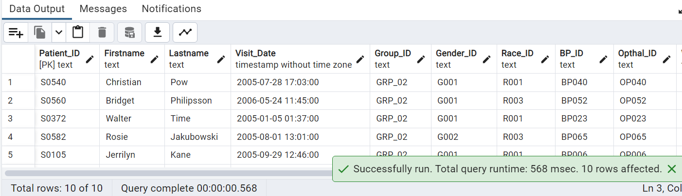

2. Please go through the below screenshot and create the exact output

select CONCAT("Firstname", ' ', "Lastname") AS "full_name" from "Patients"

where "Lastname" like 'Ma%';

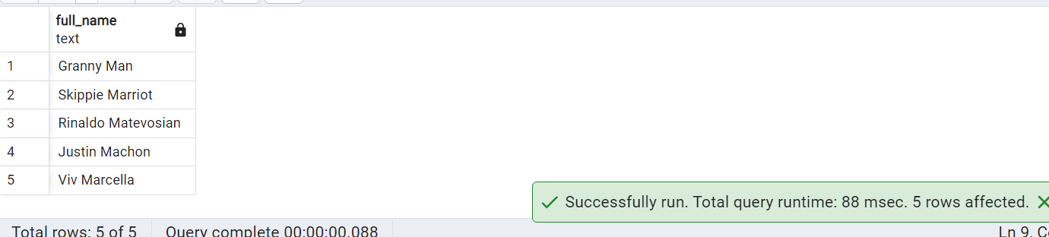

3. Write a query to get a list of patients whose RPE start is at moderate intensity.

Select p."Patient_ID",p."Firstname",p."Lastname"

from "Patients" p

join "Walking_Test" wt on p."WalkTest_ID"=wt."WalkTest_ID"

where wt."Gait_RPE_Start " Between 4 and 6;

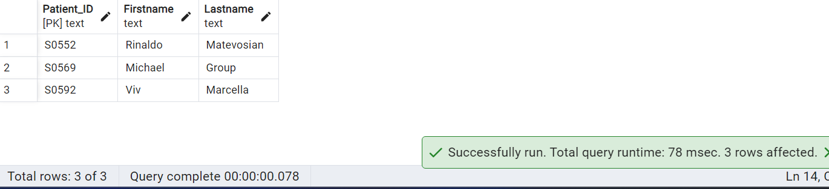

4. Write a query by using common table expressions and case statements to display birth year ranges.

with cts as

(

select

"Patient_ID",

"Firstname",

"Lastname",

"Age",

EXTRACT(YEAR FROM CURRENT_DATE) - "Age" AS "birth_year"

from

"Patients"

)

select

"Patient_ID",

"Firstname",

"Lastname",

CASE

When

birth_year IS NOT NULL

THEN

CONCAT(FLOOR(birth_year / 10)*10, '-', FLOOR(birth_year / 10)*10 + 9)

ELSE

'unknown'

END

AS "Birth_Year_Range"

From

cts;

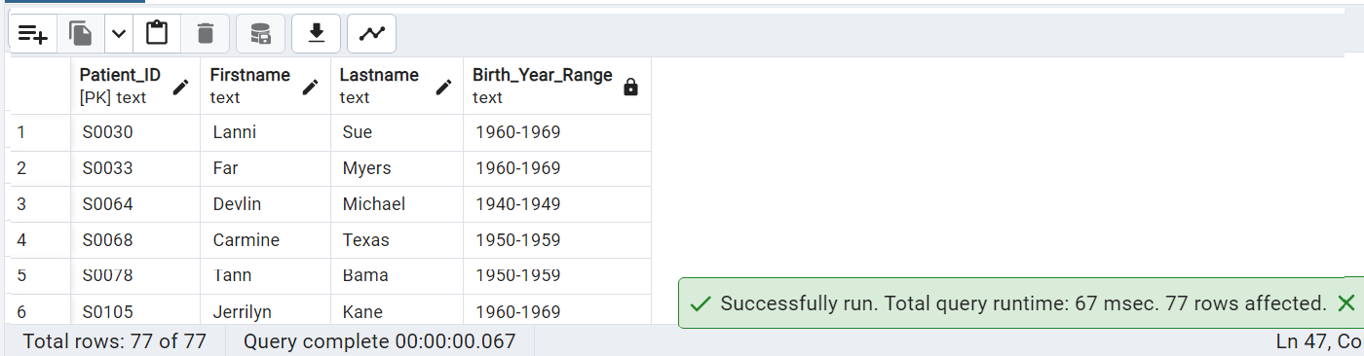

5. Display DM patient names with highest day MAP and night MAP (without using limit).

CREATE INDEX idx_patients ON public."Patients" ("Patient_ID", "Group_ID");

CREATE INDEX idx_blood_pressure ON public."Blood_Pressure" ("Patient_ID");

CREATE INDEX idx_group ON public."Group" ("Group");

WITH dm_patients AS (

SELECT

P."Firstname",

P."Lastname",

((2 * BP."24Hr_Day_DBP") + BP."24Hr_Day_SBP") / 3 AS day_map,

((2 * BP."24Hr_Night_DBP") + BP."24Hr_Night_SBP") / 3 AS night_map,

ROW_NUMBER() OVER (ORDER BY ((2 * BP."24Hr_Day_DBP") + BP."24Hr_Day_SBP") / 3 DESC) AS rn

FROM public."Patients" P

JOIN public."Blood_Pressure" BP ON BP."Patient_ID" = P."Patient_ID"

JOIN public."Group" G ON G."Group_ID" = P."Group_ID"

WHERE G."Group" LIKE '%DM%'

)

SELECT "Firstname", "Lastname", day_map, night_map

FROM dm_patients

WHERE rn = 1;

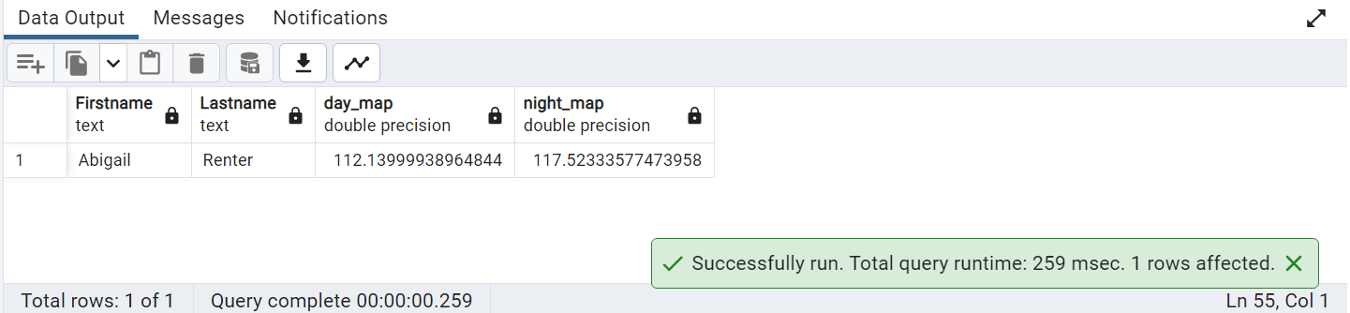

6. Create view on table Lab Test by selecting some columns and filter data using Where condition.

create or replace view bc_test_result as

select "Lab_ID","Patient_ID","WBC","Platelets" from "Lab_Test"

where "WBC" between 3 and 6;

select * from bc_test_result;

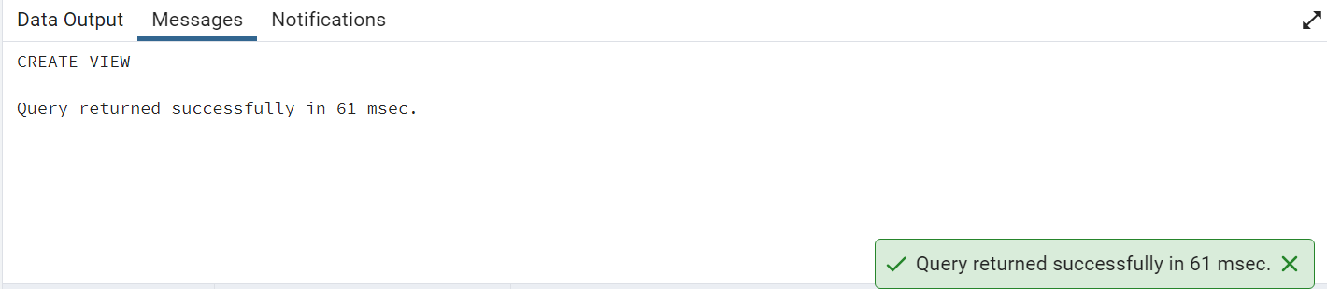

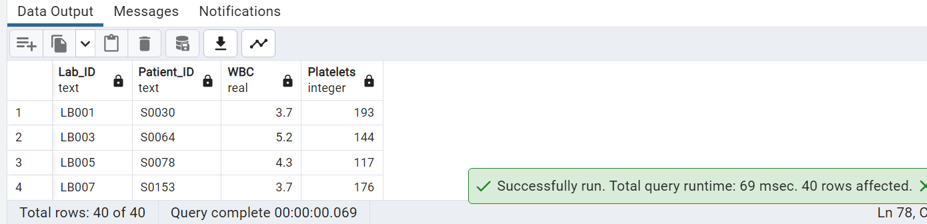

7. Display a list of Patient IDs and their Group whose diabetes duration is greater than 10 years.

select "Patient_ID","Group" from "Patients" join "Group" on "Patients"."Group_ID"= "Group"."Group_ID"

where "Diabetes_Duration" > 10;

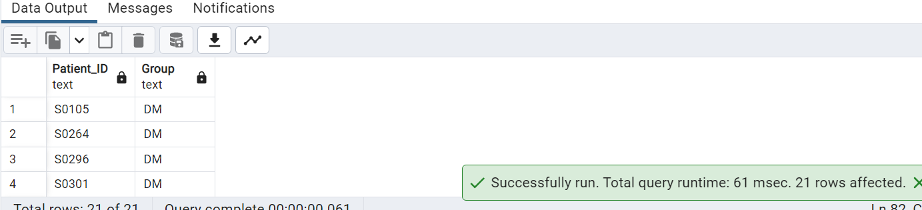

8. Write a query to list male patient ids

--and their names

--who are above 40 years of age and less than 60 years

--and have Day BloodPressureSystolic above 120 and Day BloodPressureDiastolic above 80.

select p."Patient_ID","Firstname","Lastname","Age",g."Gender",bp."24Hr_Day_SBP",bp."24Hr_Day_DBP" from "Patients" as p

join "Gender" as g on p."Gender_ID"=g."Gender_ID"

join "Blood_Pressure" as bp on bp."BP_ID"=p."BP_ID"

where g."Gender"='Male'

and p."Age" between 40 and 60

and bp."24Hr_Day_SBP" > 120 and bp."24Hr_Day_DBP" >80;

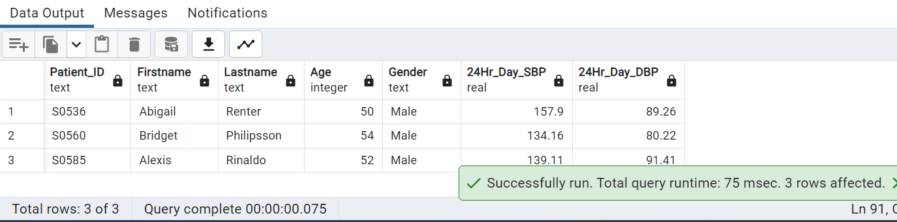

9. Use a function to calculate the percentage of patients according to the lab visited per month

CREATE OR REPLACE FUNCTION calculate_lab_visit_percentage()

RETURNS TABLE (month_name text, year integer, percentage numeric)

AS $$

DECLARE

total_visits bigint;

BEGIN

SELECT EXTRACT(YEAR FROM current_date) AS year, COUNT(DISTINCT "Patient_ID") AS total_visits

INTO year, total_visits

FROM public."Patients"

GROUP BY year;

FOR month_num IN 1..12

LOOP

SELECT TO_CHAR(DATE_TRUNC('MONTH', current_date) + (month_num - 1) * INTERVAL '1 MONTH', 'Month') AS month_name, year,

(COUNT(DISTINCT "Patient_ID") * 100) / total_visits

INTO month_name, year, percentage

FROM public."Patients"

WHERE EXTRACT(MONTH FROM "Visit_Date") = month_num

GROUP BY month_name, year

ORDER BY EXTRACT(MONTH FROM DATE_TRUNC('MONTH', current_date) + (month_num - 1) * INTERVAL '1 MONTH');

RETURN NEXT;

END LOOP;

END;

$$ LANGUAGE plpgsql;

select * from calculate_lab_visit_percentage();

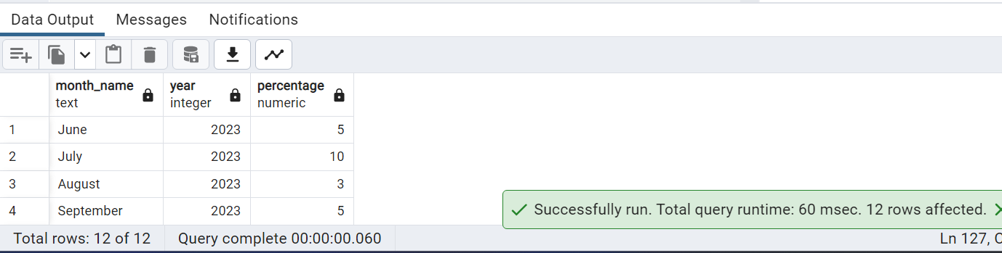

10. Count of patients by first letter of firstname.

select left("Firstname",1) as firstletter, count(1) from "Patients"

group by firstletter;

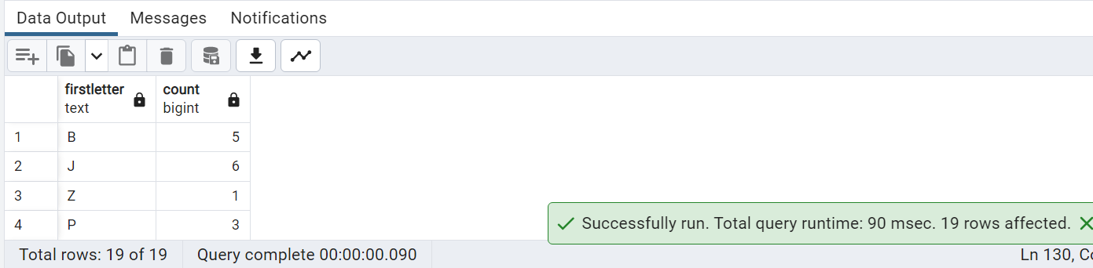

11) write a query to get the list of patients whose lipid test value is null

SELECT * FROM "Lipid_Lab_Test" where "Fasting_Cholestrol" IS NULL

OR "Fasting_Triglyc" IS NULL

OR "Fasting_HDL" IS NULL

OR "Fasting_LDL" IS NULL;

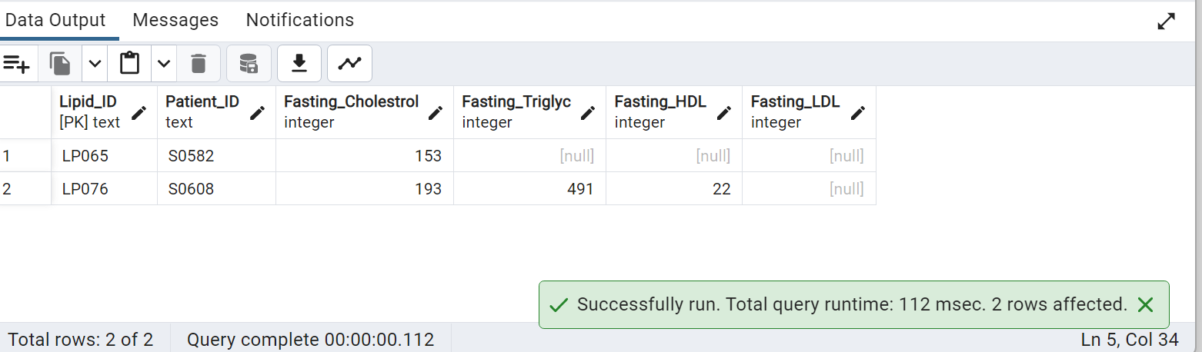

12)Create a stored procedure to make user ids for the given patient id

create or replace procedure GenerateUserID(patient_id int)

language plpgsql

as $$

Declare

userID varchar(20);

usernumber Integer;

Begin

--usernumber is calculated by multiplying by 1000

usernumber:=patient_id*1000;

--concatenate 'UID' with the converted userNumber to VARCHAR and assigns it to userId.

userId:='UID' || usernumber::VARCHAR;

--raise a notice message with generated userID

RAISE NOTICE 'Generated User ID: %' , userID;

End;

$$;

--Call procedure by passing PatientID as argument

call GenerateUserID(12345);

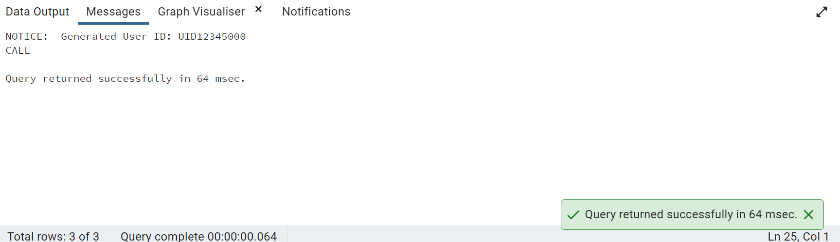

13)Display Patients With LastName contains 'Po' and replace it with 'Be'.

SELECT "Patient_ID","Firstname","Lastname",REPLACE("Lastname",'Po','Be') As "New LASTNAME"

FROM public."Patients"

WHERE "Lastname" LIKE 'Po%';

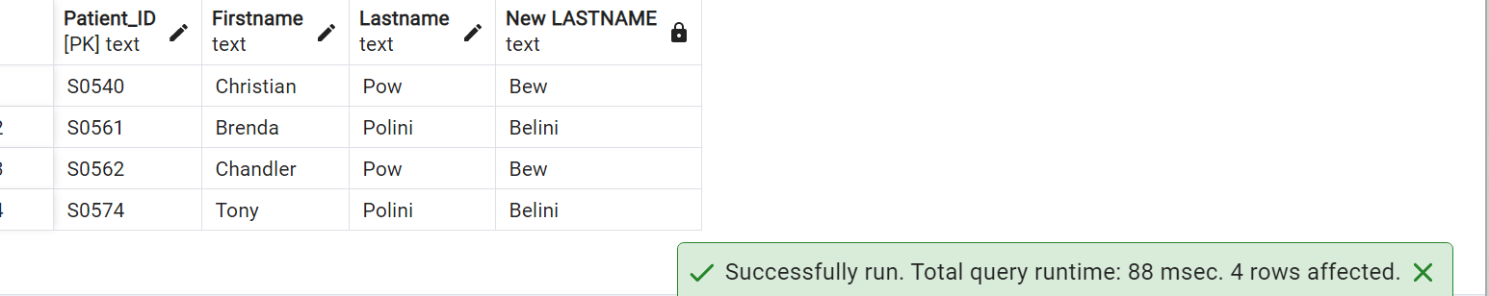

14)Calculate the patient's birth year in descending order

SELECT CONCAT("Firstname",' ',"Lastname") As "Patient Name",

(Extract(year from "Visit_Date"))-"Age" as "Birth Year"

FROM public."Patients"

ORDER BY "Birth Year" DESC;

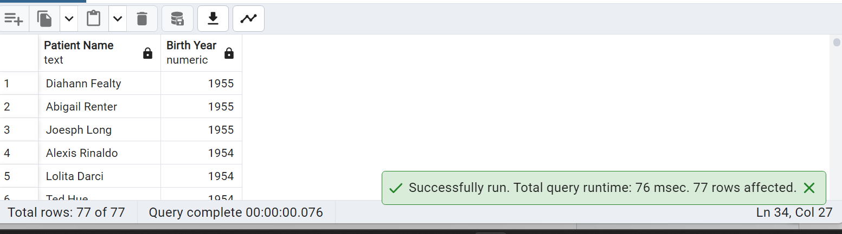

15) Find the patients that have eye damage due to diabetes.

SELECT CONCAT(p."Firstname", ' ', p."Lastname") AS "Patients With Eye Damage"

FROM public."Patients" p

JOIN public."Opthalmology" o ON p."Opthal_ID" = o."Opthal_ID"

-- Filter the rows where either "Diabetic_Retinopathy" or "Macular_Edema" > 0

WHERE (o."Diabetic_Retinopathy" > 0 OR o."Macular_Edema" > 0)

GROUP BY "Patients With Eye Damage";

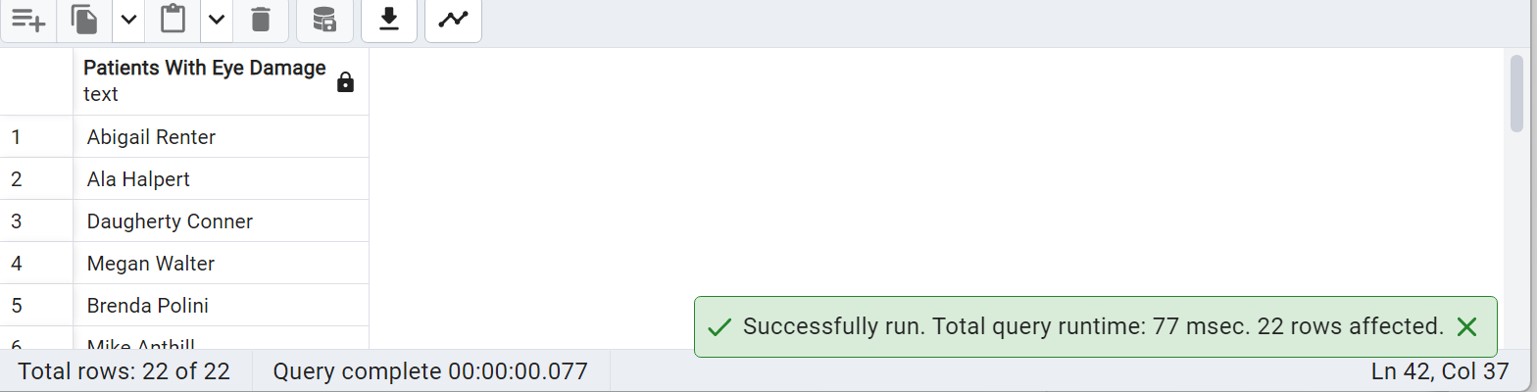

16)Query to classify Gait RPE End into 5 categories as per the intensity. (Hint: Use of CASE statement)

SELECT "Patient_ID",

CASE WHEN "Gait_RPE_End "= 0 THEN 'Rest'

WHEN "Gait_RPE_End " BETWEEN 1 AND 3 THEN 'EASY INTENSITY'

WHEN "Gait_RPE_End " BETWEEN 4 AND 6 THEN 'MODERATE INTENSITY'

WHEN "Gait_RPE_End " BETWEEN 7 AND 9 THEN 'HARD INTENSITY'

WHEN "Gait_RPE_End " = 10 THEN 'MAX EFFORT INTENSITY'

END

FROM public."Walking_Test";

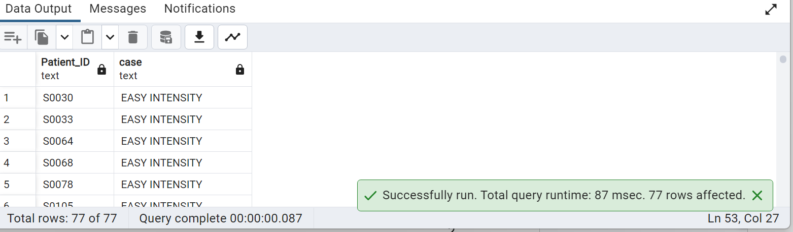

17) Create view on patient table with check constraint condition

CREATE VIEW Vw_Patient_Senior as

SELECT "Patient_ID","Firstname", "Lastname","Age" FROM public."Patients"

WHERE "Age">70;

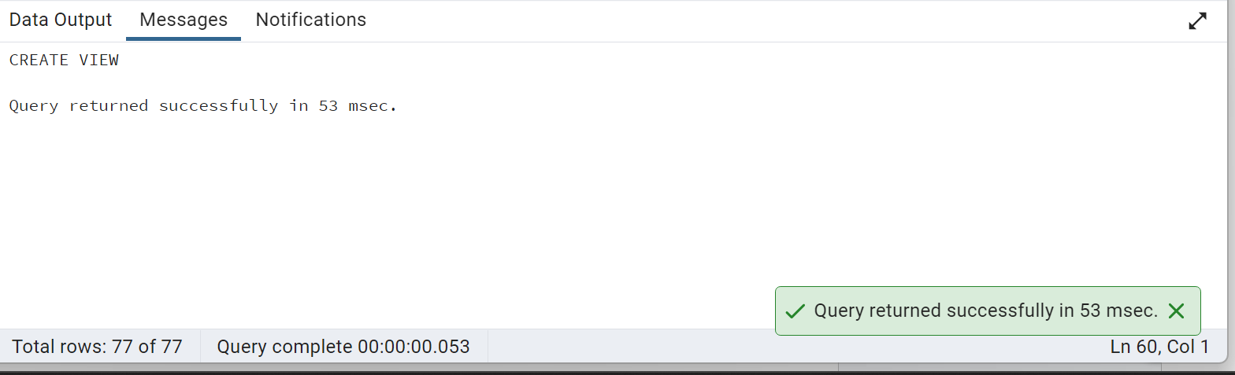

SELECT * FROM Vw_Patient_Senior;

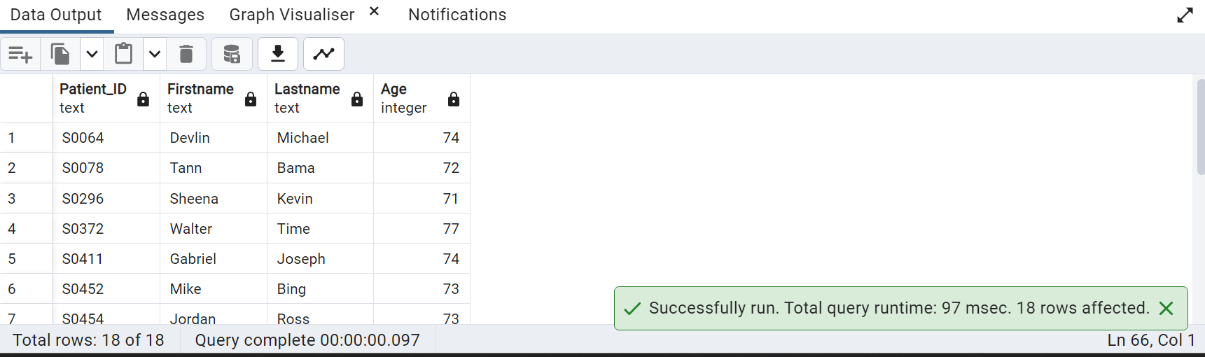

18) Calculate the patient's current age

-- Subtracting Visit_Date from current year and adding Age at Visit time gives patients' Current Age

SELECT (Extract(year from now()))-(Extract(year from "Visit_Date"))+"Age" as "Patients Current Age"

FROM public."Patients";

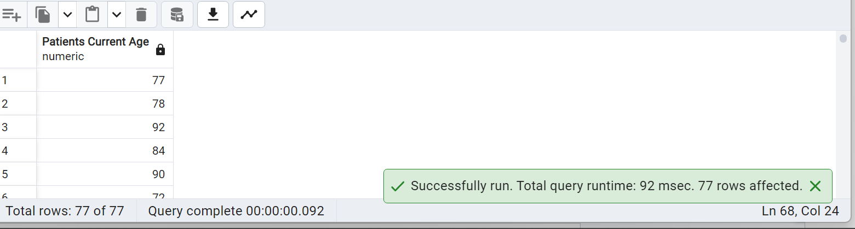

19) Write a query to display Mr. or Ms. as prefix to patients’ names with respect to gender.

SELECT CASE WHEN G."Gender"='Male' THEN CONCAT('Mr. ', P."Firstname",' ',P."Lastname")

WHEN G."Gender"='Female' THEN CONCAT('Ms. ', P."Firstname",' ', P."Lastname") END

As " Prefixed Full Name"

FROM public."Patients" P, public."Gender" G

WHERE G."Gender_ID" = P."Gender_ID";

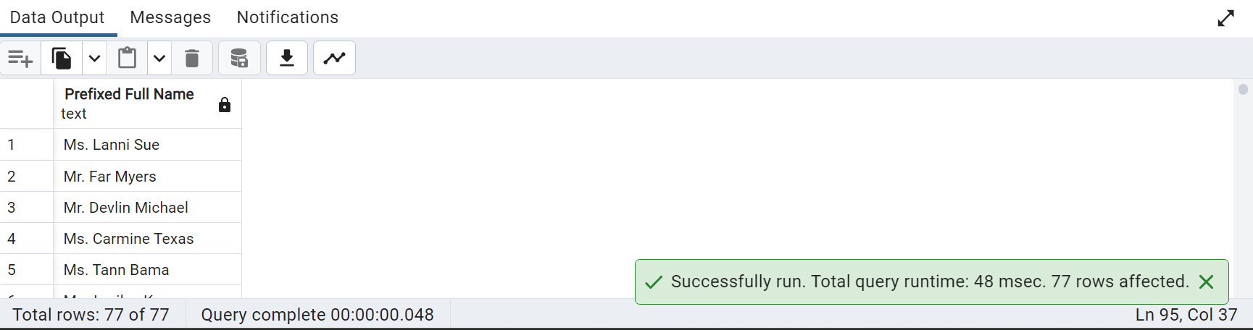

20) Write a query to get DM patient names whose distance is greater than 400 and speed is greater than 1.

SELECT CONCAT(p."Firstname", ' ', p."Lastname") AS "Patient", wt."Gait_DT_Distance", wt."Gait_DT_Speed"

FROM public."Patients" p

JOIN public."Walking_Test" wt ON p."Patient_ID"=wt."Patient_ID"

WHERE "Gait_DT_Distance">400 AND "Gait_DT_Speed" > 1;

21)Create a trigger to raise notice and prevent the deletion of a record from a view.

CREATE VIEW PatientsView

AS

SELECT pnt."Patient_ID",pnt."Firstname", pnt."Lastname", pnt."Visit_Date",pnt."Age", pnt."Height", pnt."BMI",

grp."Group",gnr."Gender",race."Race",bp."24Hr_Day_SBP",bp."24Hr_Day_DBP",bp."24Hr_Day_HR",

opt."Diabetic_Retinopathy", opt."Macular_Edema", lr."Lipid_ID", lr."Lab_ID"

FROM public."Patients" AS pnt

INNER JOIN public."Group" AS grp ON pnt."Group_ID" = grp."Group_ID"

INNER JOIN public."Gender" AS gnr ON pnt."Gender_ID" = gnr."Gender_ID"

INNER JOIN public."Race" AS race ON pnt."Race_ID" = race."Race_ID"

INNER JOIN public."Blood_Pressure" AS bp ON pnt."BP_ID" = bp."BP_ID"

INNER JOIN public."Opthalmology" AS opt ON pnt."Opthal_ID" = opt."Opthal_ID"

INNER JOIN public."Link_Reference" AS lr ON pnt."Link_Reference_ID" = lr."Link_Reference_ID"

;

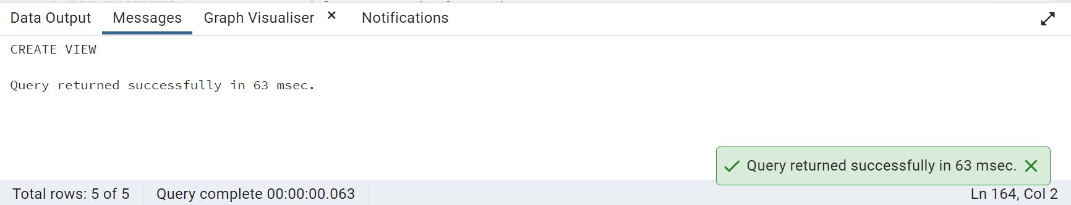

CREATE FUNCTION patient_prevent_delete()

RETURNS TRIGGER

AS $$

BEGIN

RAISE EXCEPTION 'You cannot delete records from View';

END;

$$

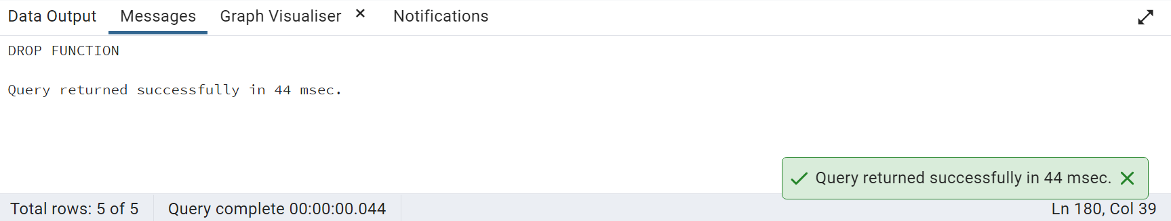

CREATE TRIGGER TG_PATIENT_PREVENT_DELETE

INSTEAD OF DELETE

ON PatientsView

FOR EACH ROW

EXECUTE PROCEDURE patient_prevent_delete();

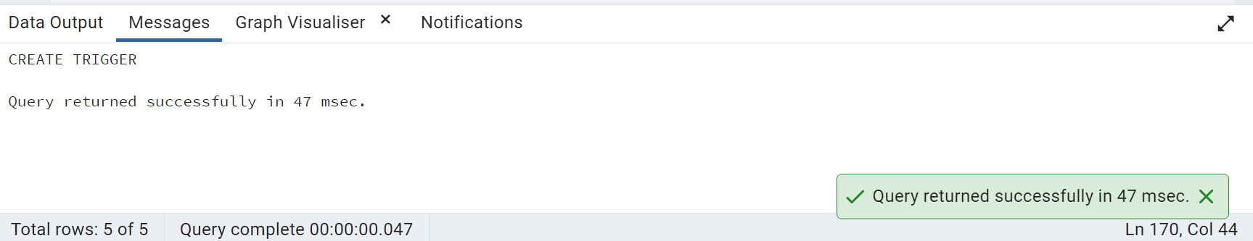

DELETE FROM patientsview WHERE "Patient_ID"='S0030';

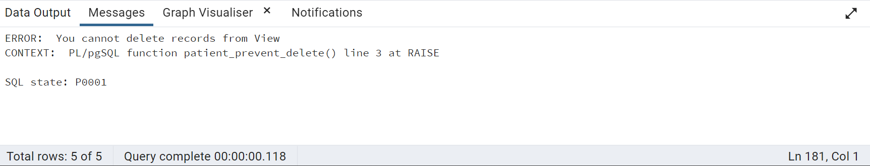

22)Select the patient's full name with a name starting with 's'

– followed by any character, followed by 'r', followed by any character, followed by b.

SELECT CONCAT("Firstname",

"Lastname") as "fullname"

FROM "Patients"

WHERE CONCAT("Firstname",

"Lastname") iLIKE 's%r%b%';

--TO MATCH CASE INSENSITIVE CASES WE USE "ILIKE" IN POSTGRES NOT STANDARD TO SQL BUT AS POSTGRES EXTENSION"

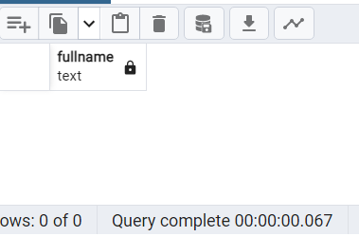

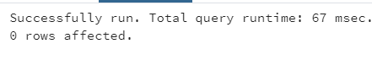

23).write a query to get which race has the maximum number of Diabetic patients.

SELECT "Race"

FROM "Race"

WHERE "Race_ID" =

(SELECT "Race_ID"

FROM "Patients"

WHERE "Diabetes_Duration" != 0

GROUP BY "Race_ID"

ORDER BY COUNT("Race_ID") DESC

LIMIT 1);

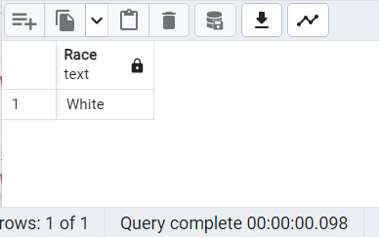

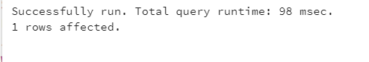

--24.Find the list of Patients who has leukopenia.

SELECT LT."Patient_ID",P."Firstname",P."Lastname"

FROM public."Lab_Test" LT

JOIN public."Patients" P ON P."Patient_ID" = LT."Patient_ID"

WHERE "WBC"<3;

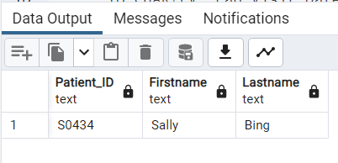

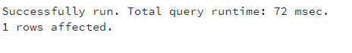

25.Get the number of patients in the year 2005 in each of the Genesis and Cultivate labs.

SELECT "Lab_names",

COUNT ("Lab_visit_ID")NUMOFPATIENTS

FROM PUBLIC."Lab_Visit"

WHERE "Lab_names" in ('Cultivate Lab','Genesis Lab')

AND (EXTRACT(YEARFROM "Lab_Visit_Date")) = 2005

GROUP BY "Lab_names";

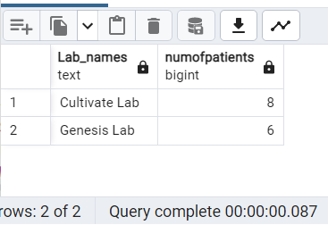

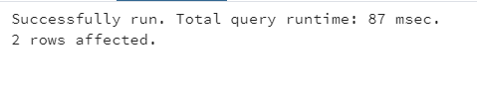

26.Write a query to get a list of patient IDs' and their Fasting Cholesterol in February 2006.

SELECT LLT."Patient_ID",

LLT."Fasting_Cholestrol",

TO_CHAR(LV."Lab_Visit_Date",'MONTH')AS MONTH,

TO_CHAR(LV."Lab_Visit_Date",'YYYY')AS YEAR

FROM PUBLIC."Lipid_Lab_Test" LLT

LEFT JOIN PUBLIC."Link_Reference" LR ON LR."Lipid_ID" = LLT."Lipid_ID"

JOIN PUBLIC."Lab_Visit" LV ON LV."Lab_visit_ID" = LR."Lab_visit_ID"

WHERE EXTRACT (YEAR FROM LV."Lab_Visit_Date") = 2006

AND EXTRACT(MONTH FROM LV."Lab_Visit_Date") = 2;

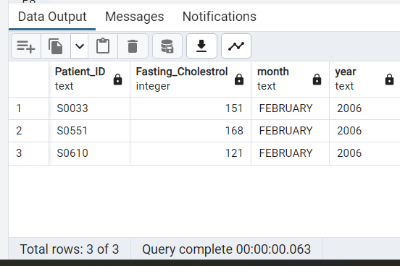

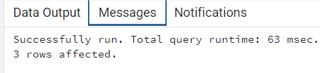

27.Write a query to get a list of patients whose first names is starting with the letter T

SELECT "Firstname"

FROM PUBLIC."Patients"

WHERE "Firstname" ILIKE 'T%';

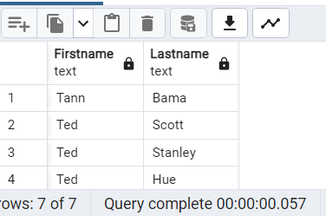

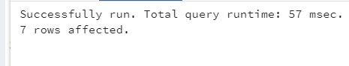

28.Find a list of Male patients whose age is more than 60 whose, BMI is more than 18.5, and whose height is more than 1.5 M.

SELECT P."Firstname",

P."Lastname"

FROM PUBLIC."Patients" P

LEFT JOIN PUBLIC."Gender" G ON G."Gender_ID" = P."Gender_ID"

WHERE G."Gender" = 'Male'

AND P."Age" > 60

AND P."BMI" > 18.5

AND P."Height" > 1.5;

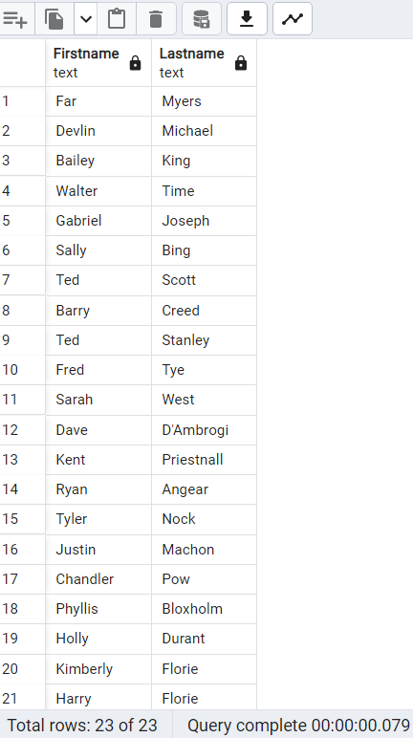

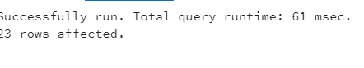

29 )Write a query to get ceiled creatinine levels for male who age is greater than 35 and levels are abnormal.

SELECT CEILING(UT."Creatinine") creatininelevel

FROM PUBLIC."Urine_Test" UT

JOIN PUBLIC."Link_Reference" LR ON LR."Urine_ID" = UT."Urine_ID"

JOIN PUBLIC."Patients" PT ON PT."Link_Reference_ID" = LR."Link_Reference_ID"

JOIN public."Gender" G ON PT."Gender_ID" = G."Gender_ID"

WHERE "Age" > 35 AND "Creatinine" NOT BETWEEN 65.4 AND 119.3 AND "Gender" = 'Male'

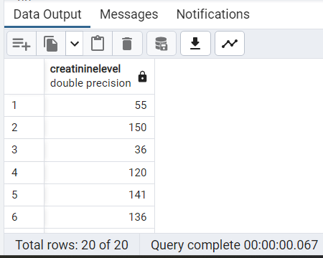

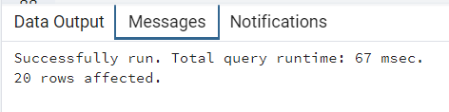

30.Write a query to get the number of patients who visited the Lab between 9 am to 12 am.

SELECT COUNT("Lab_visit_ID")

FROM PUBLIC."Lab_Visit"

WHERE EXTRACT (HOUR FROM "Lab_Visit_Date") BETWEEN 9 AND 12;

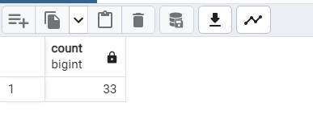

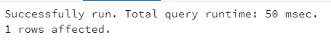

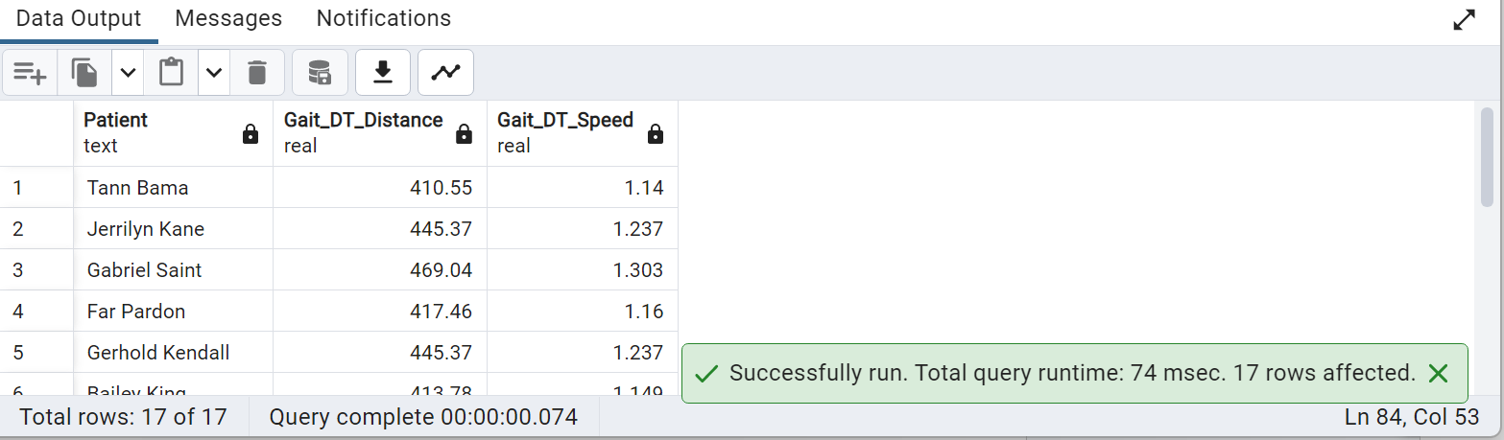

31) Write a trigger that calls a function, for checking space and case for two columns

or more before you add new data to a table.

*-- Function to check for space and case in column1 and column2*

CREATE FUNCTION check_space_and_case() RETURNS TRIGGER AS $$

DECLARE

column1_value text;

column2_value text;

BEGIN

*-- Assign the values of column1 and column2 from the new row being inserted or updated*

column1_value := NEW.column1;

column2_value := NEW.column2;

*-- Check if column1 or column2 contains a space*

IF column1_value ~ '\s' OR column2_value ~ '\s' THEN

*-- Raise an exception if a space is found in column1 or column2*

RAISE EXCEPTION 'Space is not allowed in column1 or column2';

END IF;

*-- Check if column1 or column2 is not in lowercase*

IF column1_value <> lower(column1_value) OR column2_value <> lower(column2_value) THEN

*-- Raise an exception if column1 or column2 is not in lowercase*

RAISE EXCEPTION 'Column1 or column2 must be in lowercase';

END IF;

*-- If the checks pass, return the new row*

RETURN NEW;

END;

$$ LANGUAGE plpgsql;

*-- Trigger to enforce the space and case check before inserting or updating rows in the* "Patients" table

CREATE TRIGGER space_case_check_trigger

BEFORE INSERT OR UPDATE ON public."Patients"

FOR EACH ROW

EXECUTE FUNCTION check_space_and_case();

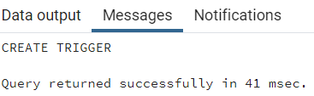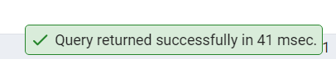

32) Write a query to calculate the running moving averages of diabetes_duration for Group 2 using the moving windows/sliding dynamic average windows.

SELECT "Patient_ID", "Firstname", "Lastname","Diabetes_Duration",

*-- Calculate the moving average of diabetes duration within each group*

AVG("Diabetes_Duration") OVER (

PARTITION BY "Group_ID" ORDER BY "Patient_ID" ROWS BETWEEN UNBOUNDED PRECEDING AND CURRENT ROW

) AS moving_average

FROM "Patients"

WHERE "Group_ID" = 'GRP_02';

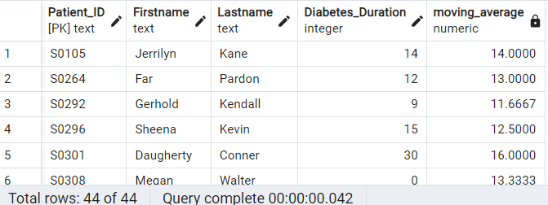



33) Write a query to create a table to get patients’ demographic details whose birth year is 1939.Name the table as “Patient_Detail”

CREATE TABLE public."Patient_Detail" AS

SELECT a."Patient_ID", a."Firstname", a."Lastname", g."Gender", c."Race", a."Age", a."Height", a."BMI",

(extract(year from a."Visit_Date")) - a."Age" as Birth_year

FROM public."Patients" a

JOIN public."Gender" g ON a."Gender_ID"=g."Gender_ID"

JOIN public."Race" c ON a."Race_ID"=c."Race_ID"

WHERE ((extract(year from a."Visit_Date")) - a."Age")='1939';

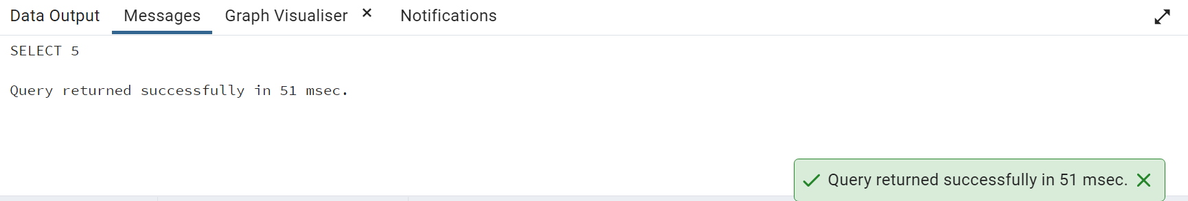

SELECT * FROM public."Patient_Detail"

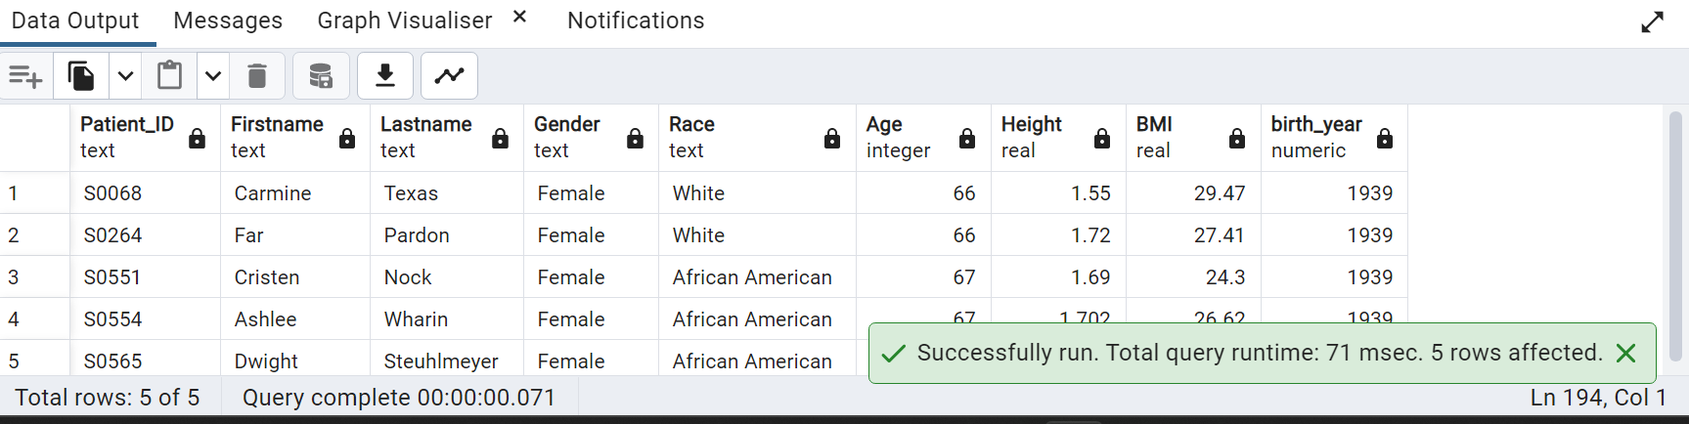

34) Convert and display Timestamp and date into visit time from Patient table on visit dates.

SELECT "Patient_ID","Firstname","Lastname",

*-- Format the visit time using the TO_CHAR() function*

TO_CHAR("Visit_Date", 'HH:MI:SS AM') AS "Visit_Time",

TO_CHAR("Visit_Date", 'YYYY-MM-DD') AS "Visit_Date"

FROM public."Patients";

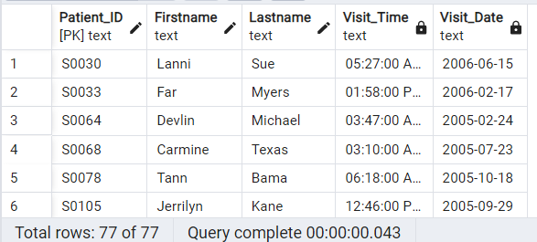



35) Write a query to find the number of patients visited each month. (Display with month Name)

SELECT TO_CHAR("Visit_Date", 'Month') AS "Month_Name",COUNT(*) AS "Number_of_Patients"

FROM "Patients"

*-- Group the data by the month extracted from the "Visit_Date" column*

GROUP BY TO_CHAR("Visit_Date", 'Month')

ORDER BY MIN("Visit_Date");

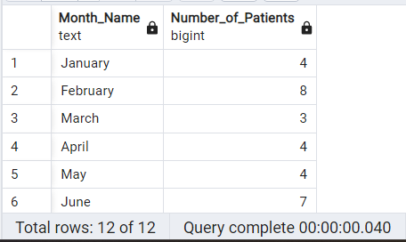



36) Write a query to get a number of visual/motor dementia patients who have any 2 abnormal conditions. (Display with condition name). (dementia/cognitive impairment: any patient who has any two abnormal test results).

SELECT COUNT(*) AS "Patient_Count",

*-- Concatenate the abnormal conditions using CONCAT_WS() function and conditional expressions*

CONCAT_WS(', ',

CASE WHEN VC."RCFT_IR" > 71 THEN 'RCFT' END,

CASE WHEN VC."TM" > 42 THEN 'TM' END,

CASE WHEN VC."Clock" <= 2 THEN 'Clock' END,

CASE WHEN MC."GDS" >= 15 THEN 'GDS' END

) AS "Abnormal_Conditions"

FROM public."Visual/Motor_Cog" VC

JOIN public."Link_Reference" LR ON LR."VM_ID" = VC."VM_ID"

JOIN public."Memory_Cognitive" MC ON LR."MC_ID" = MC."MC_ID"

WHERE (

*-- The CASE statements are used to conditionally include abnormal conditions based on specific criteria.*

CASE WHEN VC."RCFT_IR" > 71 THEN 1 ELSE 0 END +

CASE WHEN VC."TM" > 42 THEN 1 ELSE 0 END +

CASE WHEN VC."Clock" <= 2 THEN 1 ELSE 0 END +

CASE WHEN MC."GDS" >= 15 THEN 1 ELSE 0 END

) >= 2

GROUP BY "Abnormal_Conditions";

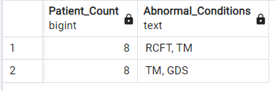



37) Write a query to get a list of patient IDs whose fasting glucose is 80, 85, and 89.

SELECT "Patient_ID"

FROM public."Lab_Test"

WHERE "Fasting_Glucose" IN (80, 85, 89);

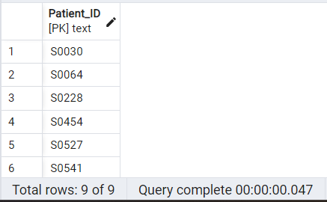



38) calculate the difference between Day and night HR. (Display 2 decimal only)

SELECT "Patient_ID",

*-- Calculate the difference between "24Hr_Day_HR" and "24Hr_Night_HR" and round it to two decimal places, ensuring a numeric data type*

ROUND(("24Hr_Day_HR" - "24Hr_Night_HR")::numeric, 2) AS "HR_Difference"

FROM "Blood_Pressure";

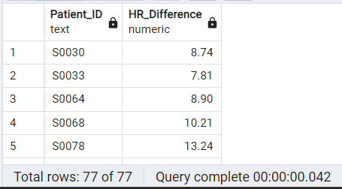



39) Find out the tables where column Patient_ID is present.(Display column position number with respective table also)

SELECT table_name,ordinal_position

FROM information_schema.columns

WHERE column_name = 'Patient_ID';

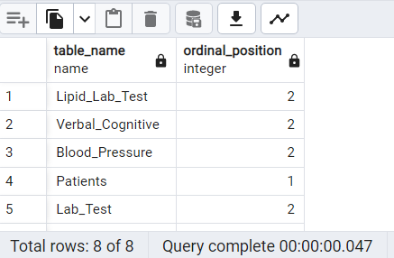



40) Write a query to calculate Creatinine ALbumin Ratio (uCAR) For DM Patients

SELECT P."Patient_ID",P."Firstname",P."Lastname",G."Group",(UT."Creatinine" / UT."Albumin") AS "Creat:Alb"

FROM public."Patients" P

JOIN "Link_Reference" LR ON P."Link_Reference_ID" = LR."Link_Reference_ID"

JOIN "Urine_Test" UT ON LR."Urine_ID" = UT."Urine_ID"

JOIN "Group" G ON P."Group_ID" = G."Group_ID"

JOIN public."Patients" DM ON P."Patient_ID" = DM."Patient_ID"

WHERE DM."Group_ID" IN (

SELECT "Group_ID"

FROM "Group"

WHERE "Group" = 'DM');

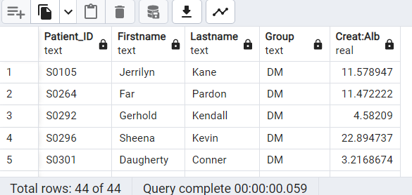



41. write a query to get the number of patients whose urine creatinine is in a normal range (Gender wise).

SELECT G."Gender", COUNT(P."Patient_ID") AS "Number of Patients"

FROM public."Patients" P

JOIN public."Gender" G ON G."Gender_ID" = P."Gender_ID"

JOIN public."Link_Reference" LR ON LR."Link_Reference_ID" = P."Link_Reference_ID"

JOIN public."Urine_Test" U ON U."Urine_ID" = LR."Urine_ID"

WHERE

(G."Gender" = 'Male' AND U."Creatinine" BETWEEN 65.4 AND 119.3) OR

(G."Gender" = 'Female' AND U."Creatinine" BETWEEN 52.2 AND 91.9)

GROUP BY G."Gender";

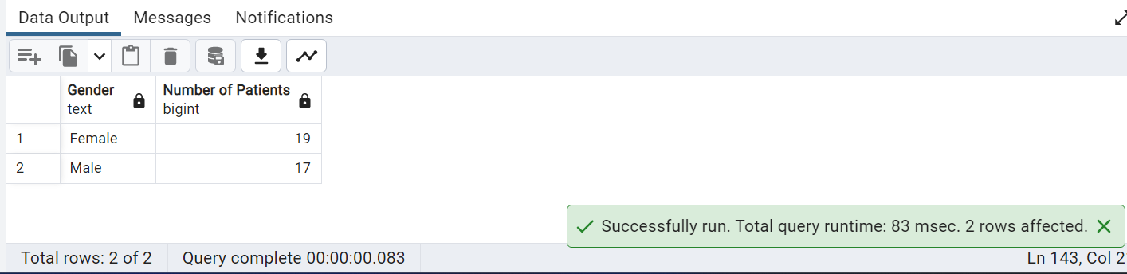

42.Write a query to update id LB002 with the lab name Cultivate Lab

select * from "Lab_Visit"

where "Lab_visit_ID"='LB002'

update "lab_visit"

set "Lab_visit_ID"='LB002'

where "Lab_names"='Cultivate Lab'

select "Lab_names" from "Lab_Visit"

where "Lab_names"='Cultivate Lab'

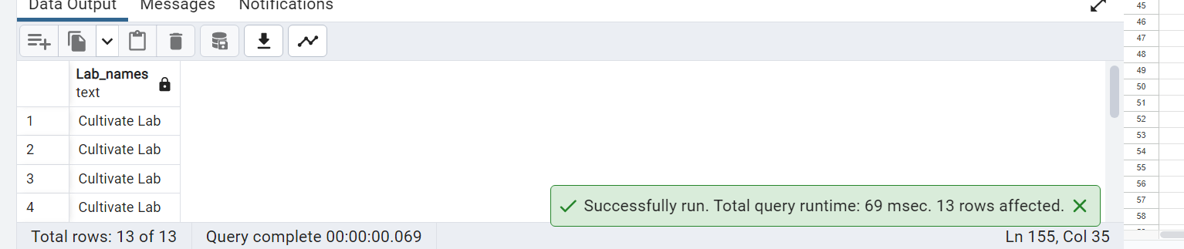

43. Create an index on any table and use explain analyze to show differences if any.

select "Patient_ID","Firstname","Lastname","Age" from "Patients"

create index "index_firstname" on "Patients"

(

"Firstname"

)

Explain select * from public."Patients"

where "Firstname"= 'Gabriel'

drop index "index_firstname"

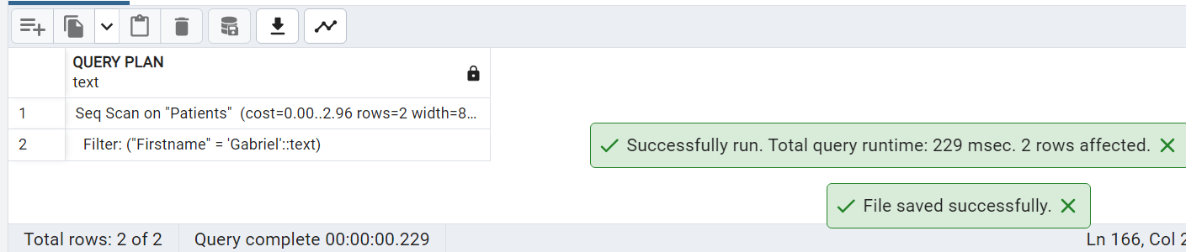

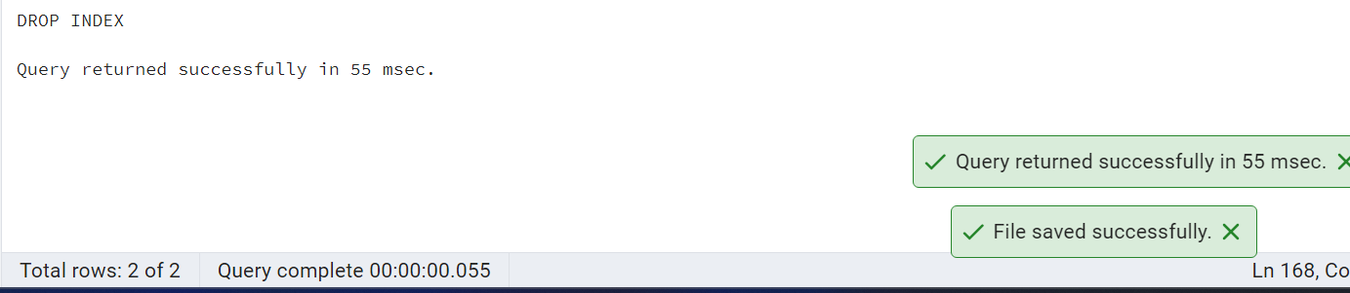

44.Write a query to split the lab visit date into two different columns lab_visit_date and lab_visit_time.

select CAST ("Lab_Visit_Date" AS DATE) as lab_visit_date, CAST ("Lab_Visit_Date" AS TIME) as lab_visit_time from "Lab_Visit"

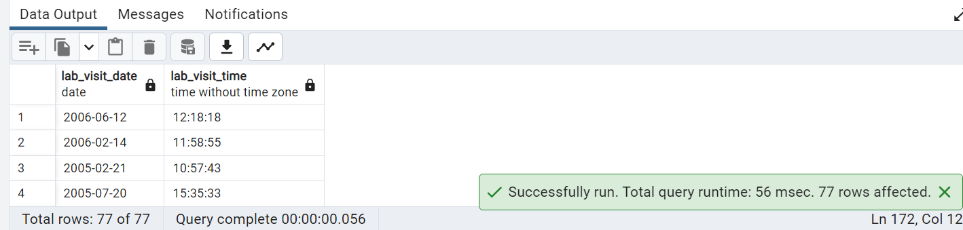

45 Please go through the below screenshot and create the exact output.

SELECT SUBSTRING("Patient_ID" FROM 2)::INTEGER AS "pat_id",

CASE WHEN SUBSTRING("Patient_ID" FROM 2)::INTEGER % 2 = 0 THEN 'true' ELSE 'false' END AS "even",

CASE WHEN SUBSTRING("Patient_ID" FROM 2)::INTEGER % 2 = 0 THEN 'false' ELSE 'true' END AS "odd"

FROM "Patients";

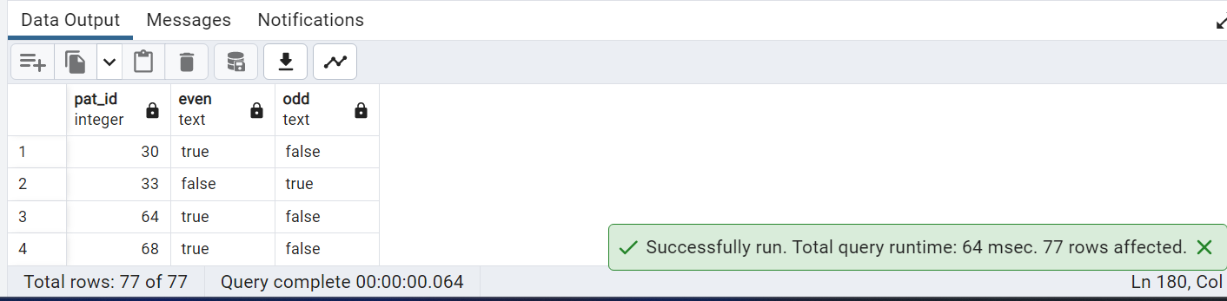

46 Calculate the Number of Diabetic Male and Female patients who are Anemic

SELECT G."Gender", COUNT(DISTINCT CASE

WHEN (G."Gender" = 'Male' AND LT."Hgb" < 13.2)

OR (G."Gender" = 'Female' AND LT."Hgb" < 11.6)

THEN P."Patient_ID"

END) AS anemic_count

FROM public."Patients" P

JOIN public."Gender" G ON G."Gender_ID" = P."Gender_ID"

JOIN public."Lab_Test" LT ON LT."Patient_ID" = P."Patient_ID"

WHERE P."Patient_ID" IN (

SELECT "Patient_ID"

FROM public."Patients"

WHERE "Diabetes_Duration" > 0)

GROUP BY G."Gender";

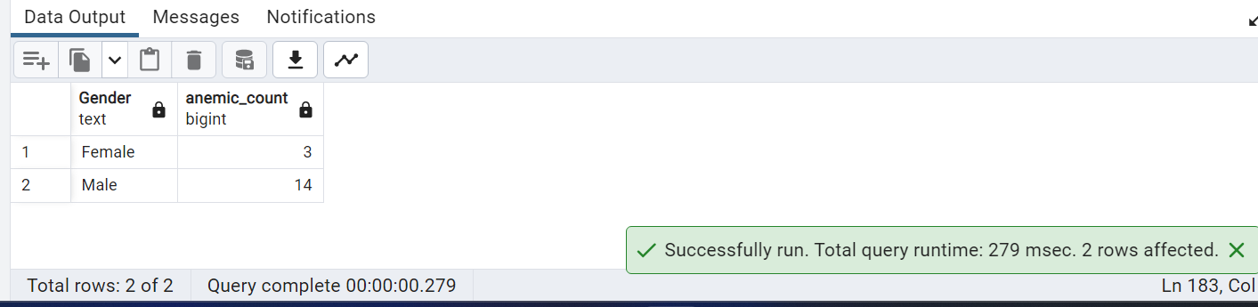

47. Write a query to display the Patient_ID, last name, and the position of the substring 'an' in the last name column for those patients who have a substring 'an'.

SELECT "Patient_ID", "Lastname",

POSITION ('an' IN "Lastname") AS "Position of 'an' in Last Name" FROM "Patients"

WHERE "Lastname" LIKE '%an%'

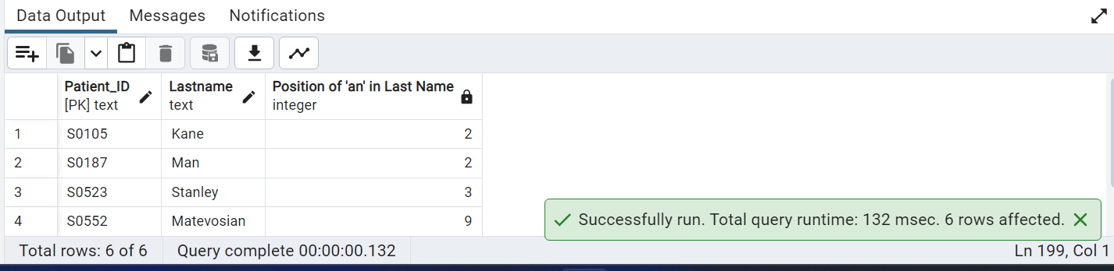

48. List of patients from rows 30-40 without using the where condition.

select "Firstname","Lastname" from "Patients"

limit 10 offset 37

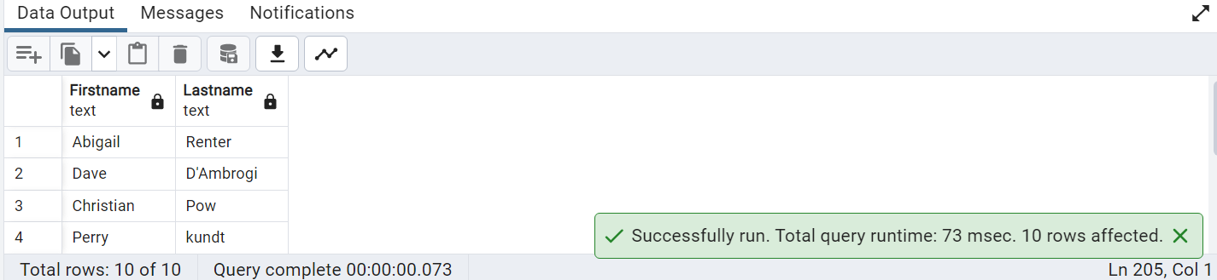

49. Write a query to find Average age for patients with high blood pressure

select avg("Age") from "Blood_Pressure"

join "Patients" as p on p."Patient_ID"="Blood_Pressure"."Patient_ID"

where "Blood_Pressure"."24Hr_Day_SBP" > 129 and "Blood_Pressure"."24Hr_Night_SBP" >129

and "Blood_Pressure"."24Hr_Day_DBP" >79 and "Blood_Pressure"."24Hr_Night_DBP" >79

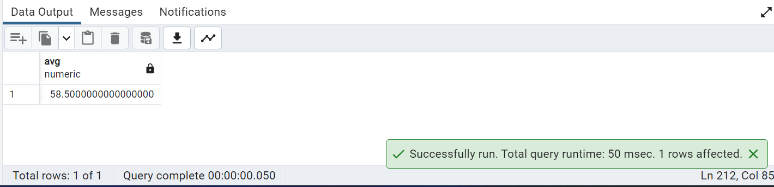

50.Create materialized view with no data, to display no of male and female patients.

CREATE MATERIALIZED VIEW Number_Of_Gender

AS

select G."Gender",count(G."Gender") "No_Of_Gender" from

"Patients" P

inner join "Gender" G on G."Gender_ID"=P."Gender_ID"

group by G."Gender"

WITH NO DATA;

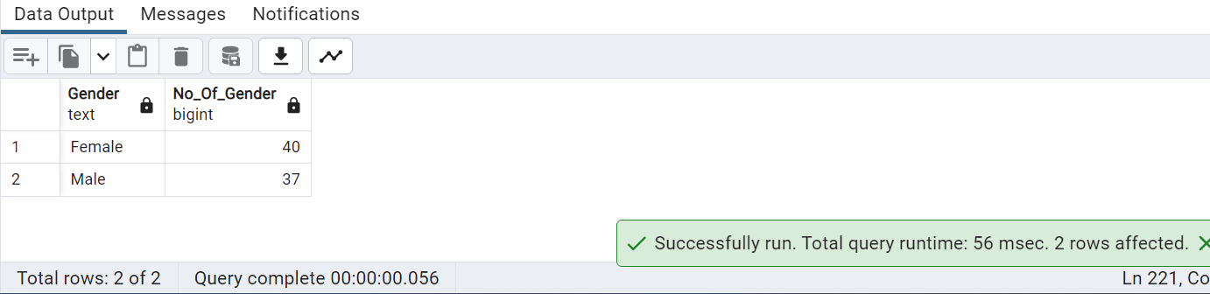

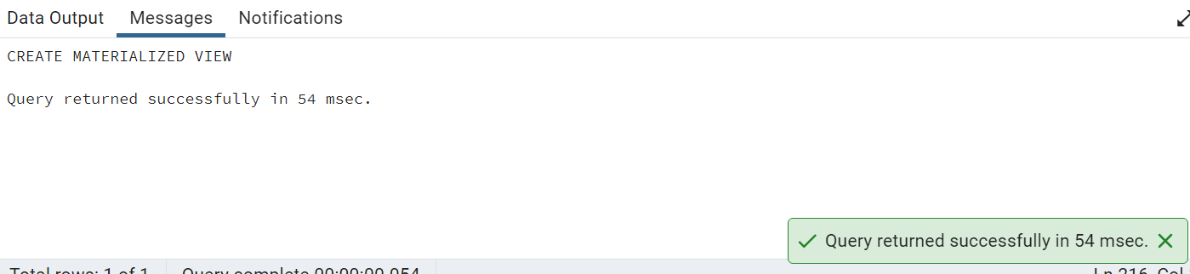

—

51)Get a list of unique lab names whose names is starting with G and end with b.

SELECT DISTINCT("Lab_names") FROM public."Lab_Visit"

WHERE "Lab_names" LIKE 'G%b';

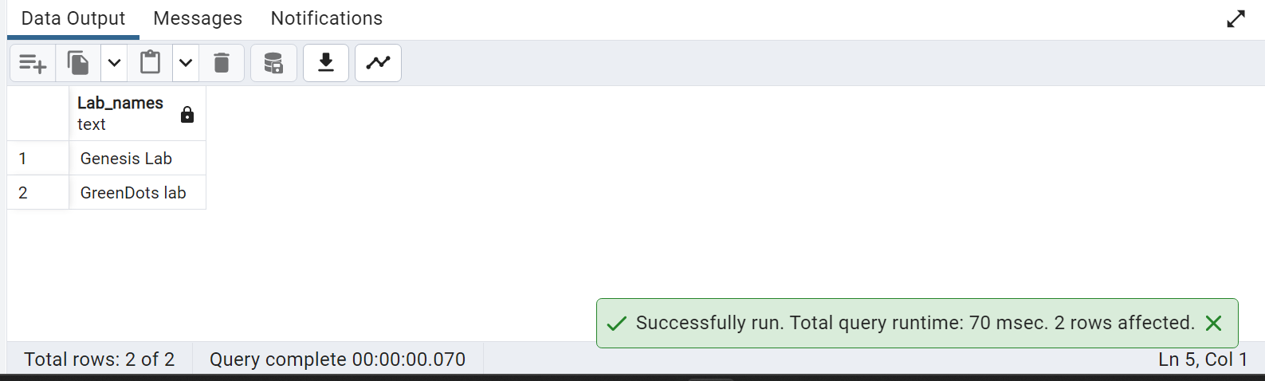

52)Write the query to create an Index on table Verbal_Cognitive by selecting a column and also write the query drop the same index.

– index created on Verbal Cognitive table based on VC_ID column

CREATE INDEX idx_verbal_cognitive_vc_id ON public."Verbal_Cognitive"("VC_ID");

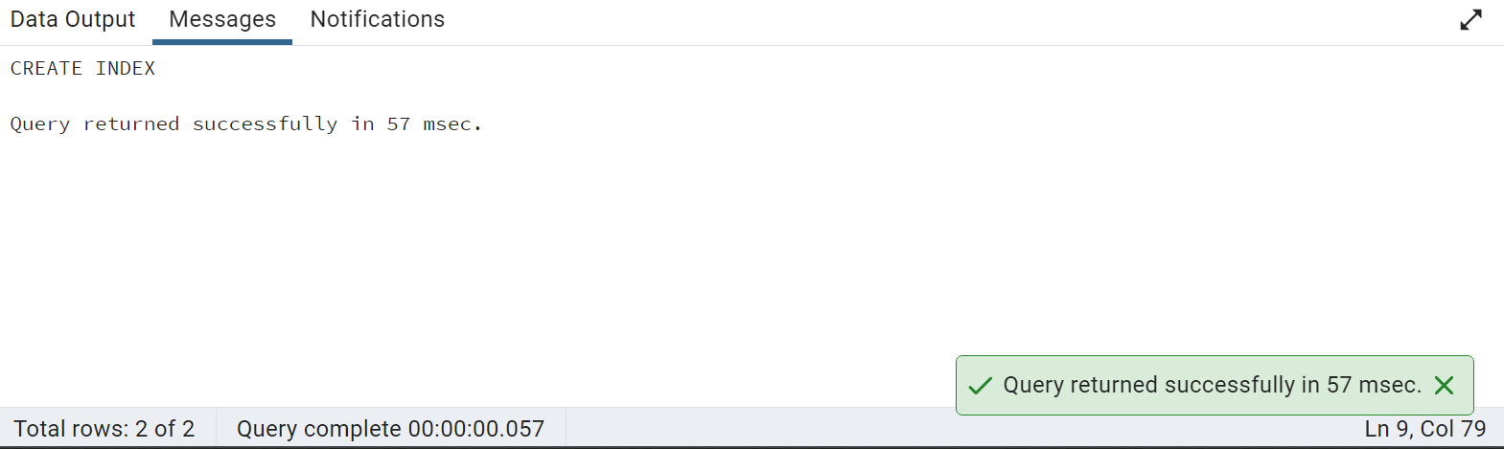

DROP INDEX idx_verbal_cognitive_vc_id;

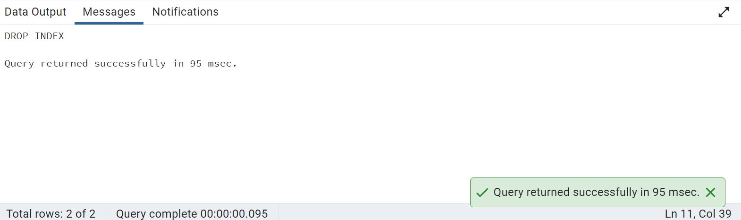

53) Get the number of patients born in a leap year.

–Birth Year is calculated and MOD function is used to calculate remainder to check if birth year is a leap year

SELECT COUNT(*)As "Patients born in Leap Year" FROM public."Patients"

WHERE MOD(((Extract(year from "Visit_Date"))-"Age"),4)=0;

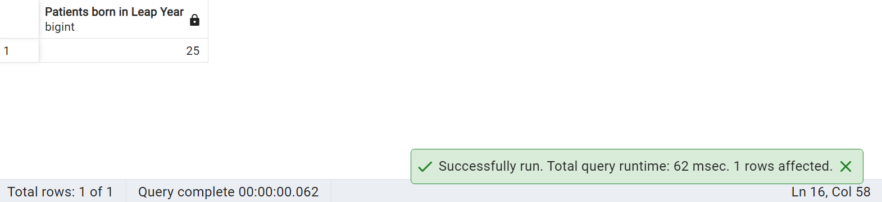

54) Write a query to get a list of patient IDs from the DM group and above age 60 in sequence.

SELECT p."Patient_ID",p."Age" FROM public."Patients" p

JOIN public."Group" g ON p."Group_ID"=g."Group_ID"

WHERE g."Group"='DM' AND p."Age">60

ORDER BY p."Age";

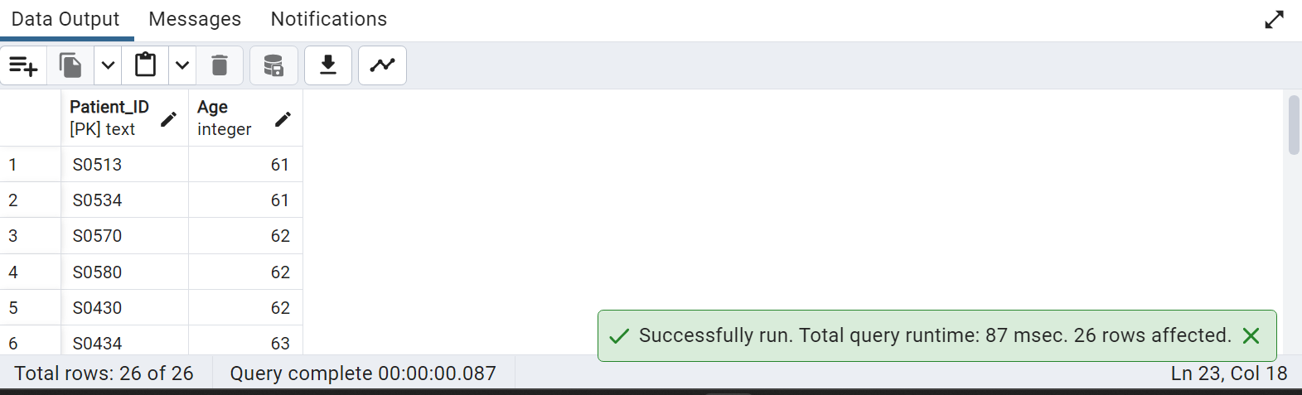

55) Find the patient who has the most damage in the eyes with the use of a max function.

WITH max_damage AS

(

– Subquery to calculate maximum diabetic retinopathy

SELECT "Opthal_ID", MAX("Diabetic_Retinopathy") AS most_damage FROM public."Opthalmology"

GROUP BY "Opthal_ID"

)

– concatenated names and highest retinopathy damage is selected

SELECT CONCAT(p."Firstname",' ', p."Lastname") As "Patient", o."Opthal_ID", o.most_damage FROM max_damage o

JOIN "Patients" p ON p."Opthal_ID" = o."Opthal_ID"

WHERE o.most_damage = (SELECT MAX(most_damage) FROM max_damage)

ORDER BY o.most_damage DESC;

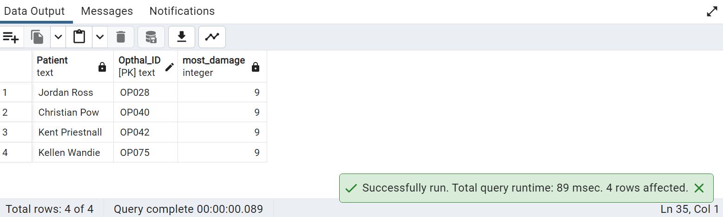

56) Create a procedure for checking if Race exists using an if else statement.

CREATE OR REPLACE PROCEDURE chk_if_race_exists(IN race_name VARCHAR)

LANGUAGE plpgsql

AS $$

BEGIN

– Check if the race exists in ‘Race’ Table

IF EXISTS(SELECT 1 FROM public."Race" WHERE "Race"=race_name)

– Raise a notice message indicating race exists

THEN RAISE NOTICE 'Race % Exists',race_name;

ELSE

– Raise a notice message indicating race does not exist

RAISE NOTICE 'Race % Does Not Exist',race_name;

END IF;

END;

$$;

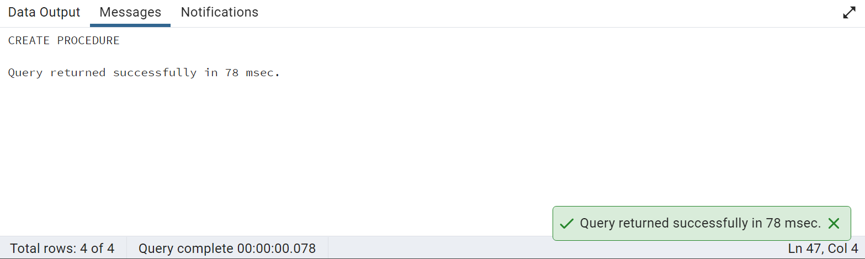

-- Check procedure with existing race

CALL chk_if_race_exists('White')

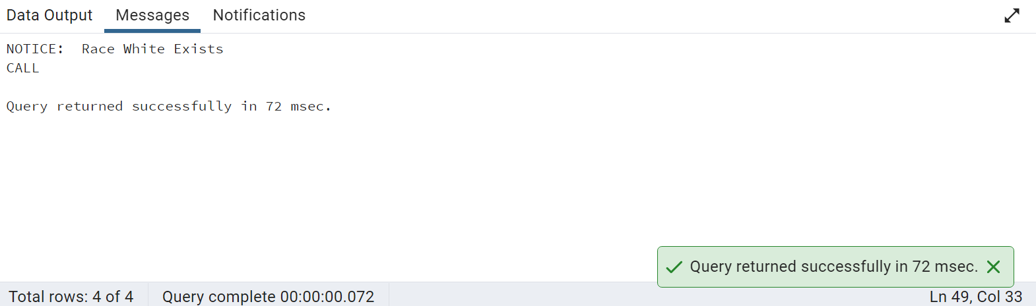

-- Check procedure with non existing race

CALL chk_if_race_exists('Asian')

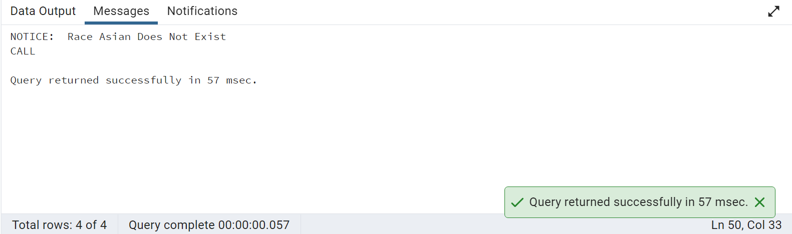

57)Write a query to display the DM patients and their high fasting triglycerides based upon their age ,gender and race.

SELECT p."Patient_ID",p."Firstname",p."Lastname",p."Age",gn."Gender",r."Race",gr."Group",llt."Fasting_Triglyc"

FROM public."Patients" p

JOIN public."Gender" gn ON p."Gender_ID"=gn."Gender_ID"

JOIN public."Race" r ON p."Race_ID"=r."Race_ID"

JOIN public."Lipid_Lab_Test"llt ON p."Patient_ID"=llt."Patient_ID"

JOIN public."Group" gr ON gr."Group_ID"=p."Group_ID"

WHERE gr."Group"='DM' AND llt."Fasting_Triglyc">150

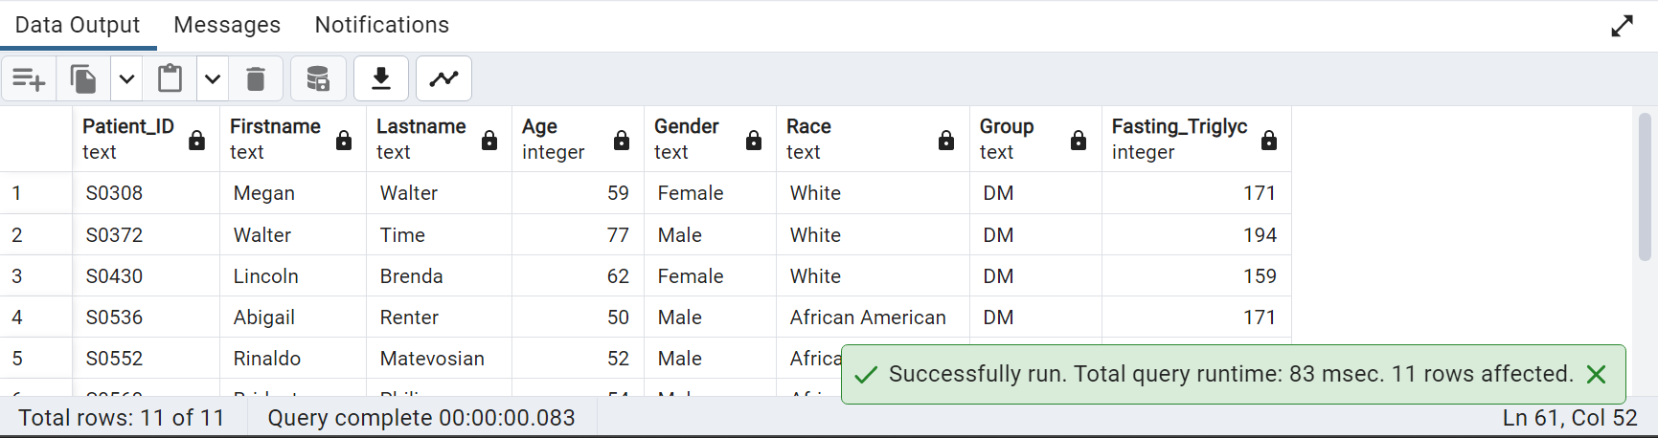

58) Create a pie chart based on race vs age.

SELECT R."Race", COUNT(*) AS Age_Count

FROM public."Patients" P

JOIN public."Race" R ON R."Race_ID" = P."Race_ID"

GROUP BY R."Race"

ORDER BY R."Race";

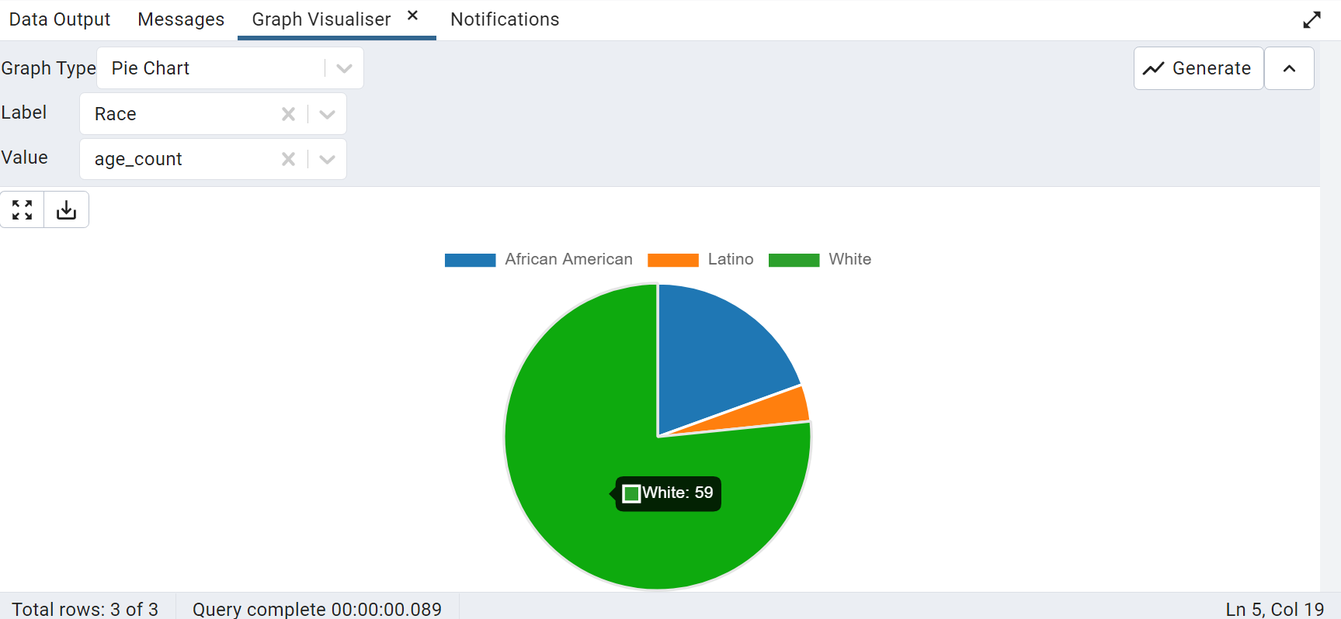

59)Write a query to create a master Patient table and its child table. Make sure that the child table inherits all the fields from the parent Patient table.

CREATE TABLE "Patient" (

"patient_id" INT PRIMARY KEY,

"Firstname" VARCHAR(50),

"last_name" VARCHAR(50),

"Visit_Date" DATE,

"Gender_ID" VARCHAR(10));

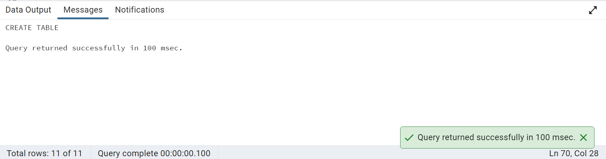

CREATE TABLE "ChildPatient" (

) INHERITS ("Patient");

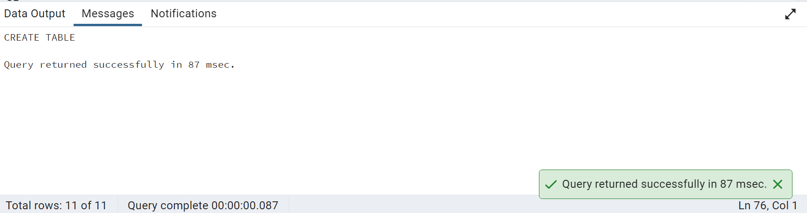

60) Write a query using the trigger after insert on the lab test table. If the patient has abnormal HbA1C and fasting glucose values.

CREATE FUNCTION fn_chk_abn_values() RETURNS TRIGGER AS $$

BEGIN

-- Check if the inserted row has abnormal HbA1C and fasting glucose values

IF NEW."Hb_A1C">5.7 AND NEW."Fasting_Glucose">100 THEN

-- Raise a notice message indicating abnormal values

RAISE NOTICE 'Abnormal HbA1C and fasting glucose values detected for patient %', NEW."Patient_ID";

END IF;

-- Return the new row to complete the trigger

RETURN NEW;

END;

$$ LANGUAGE plpgsql;

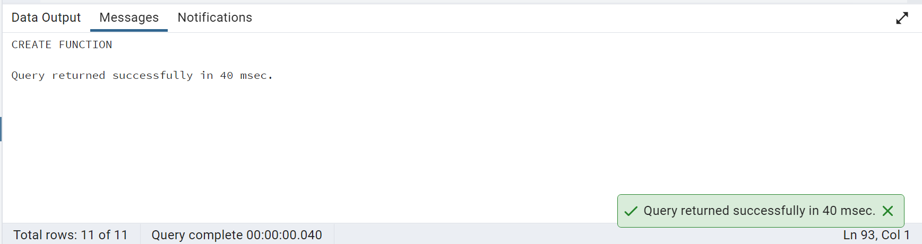

-- For each insert operation, trigger function to check abnormal values

CREATE TRIGGER chk_abn_values_trigger

AFTER INSERT ON public."Lab_Test"

FOR EACH ROW EXECUTE FUNCTION fn_chk_abn_values();

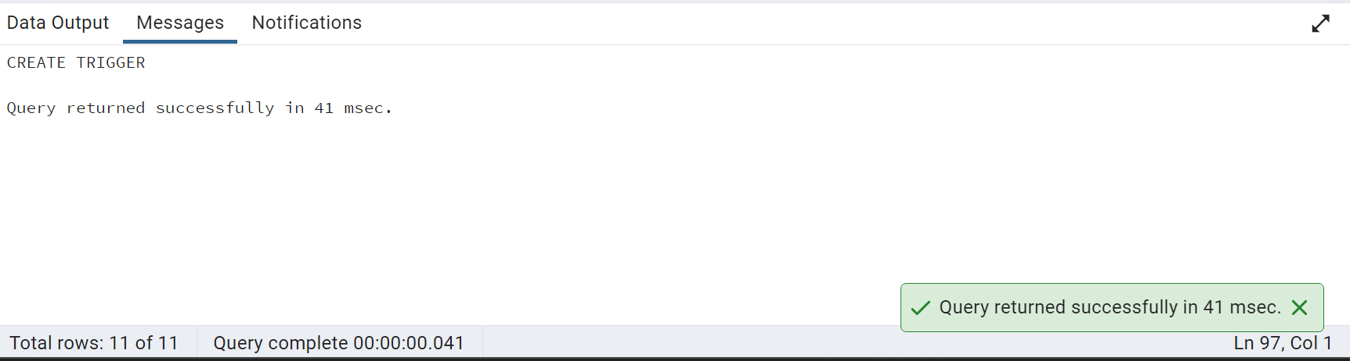

– Try to insert abnormal values in Lab test table to check trigger

INSERT INTO public."Lab_Test"("Lab_ID","Hb_A1C","Fasting_Glucose") VALUES ('LB079',6.0,120)

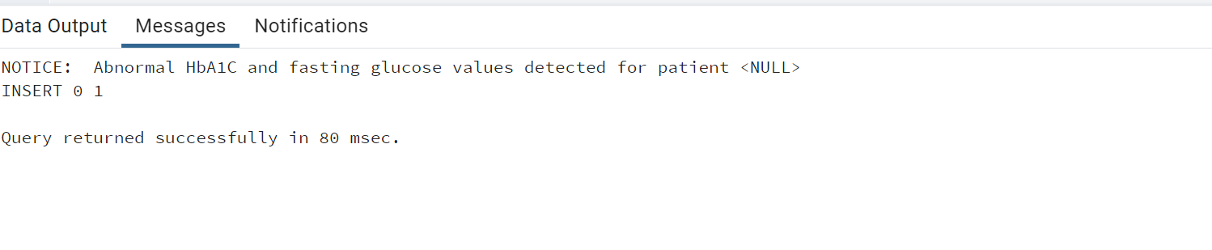

61.write a query to get the number of patients for each age bin without using the CASE statement.(Bin size - 5)

SELECT

CONCAT((WIDTH_BUCKET(p."Age", 0, 100, 20) - 1) * 5, ' - ', WIDTH_BUCKET(p."Age", 0, 100, 20) * 5 - 1) AS age_range,

COUNT (*) AS PATIENT_COUNT

FROM PUBLIC."Patients" P

GROUP BY WIDTH_BUCKET(p."Age", 0, 100, 20)

ORDER BY age_range ASC;

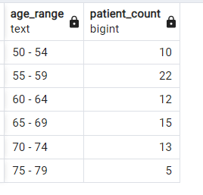



62 Write a query to get the number of patients who have normal platelets for each group.

-- /*normal platelet count in adults ranges from 150,000 to 450,000 platelets per microliter of blood.

select GP."Group_ID", count(P."Patient_ID") "patients_Count"

from "Patients" P

inner join "Gender" G on G."Gender_ID"=P."Gender_ID"

inner join "Lab_Test" LT on LT."Patient_ID"=P."Patient_ID"

inner join "Link_Reference" LR on LT."Lab_ID"=LR."Lab_ID"

inner join "Group" GP on GP."Group_ID"=P."Group_ID"

where LT."Platelets" between 150 and 450

group by GP."Group_ID"

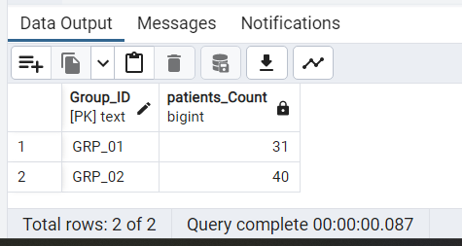

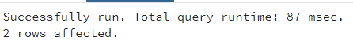

63. Create a trigger on a view of the Blood Pressure table.

– Create a view on Blood_Pressure table

CREATE OR REPLACE VIEW vw_blood_pressure

AS

(SELECT "BP_ID","Patient_ID","24Hr_Day_HR","24Hr_Night_HR"

FROM public."Blood_Pressure");

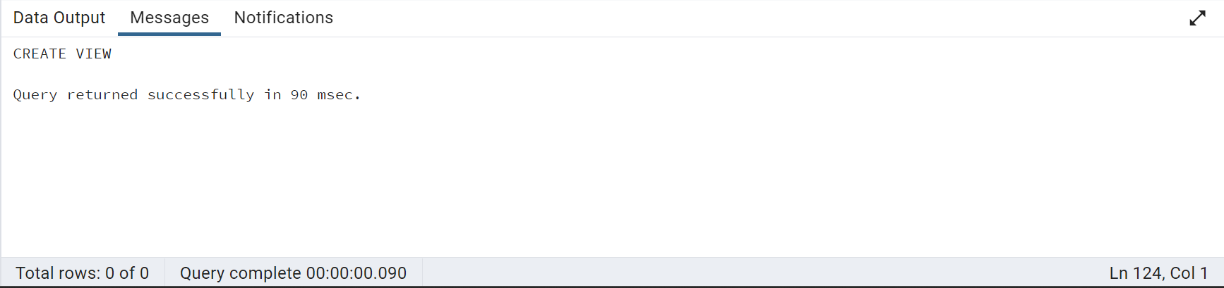

–create a function to check abnormal heart rate

CREATE OR REPLACE FUNCTION check_hr_input() RETURNS TRIGGER AS $$

BEGIN

-- Check if HR columns are inserted abnormal values

IF NEW."24Hr_Day_HR">120 OR NEW."24Hr_Night_HR" >100 THEN

RAISE NOTICE 'Abnormal Heart Rate';

END IF;

-- Return the result of the trigger function

RETURN NEW;

END;

$$ LANGUAGE plpgsql;

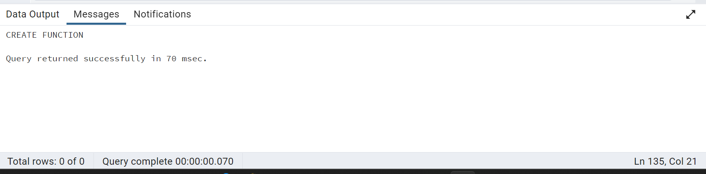

– Create a trigger on view

CREATE TRIGGER check_hr_input_trigger

INSTEAD OF INSERT ON "vw_blood_pressure"

FOR EACH ROW

EXECUTE FUNCTION check_hr_input();

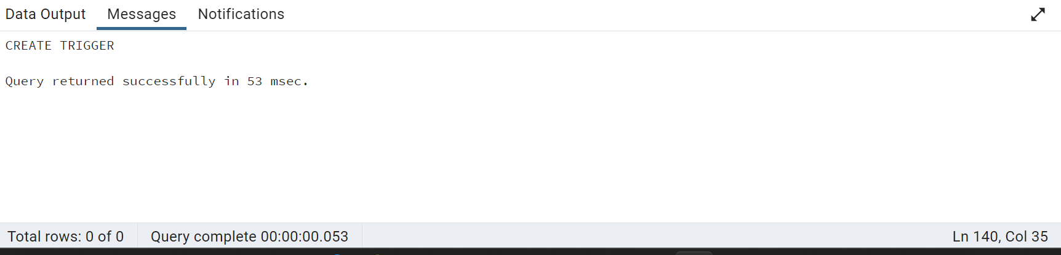

– Try inserting a record in View with abnormal HR value

INSERT INTO vw_blood_pressure("BP_ID","Patient_ID","24Hr_Day_HR","24Hr_Night_HR")

VALUES('BP079','S0612',125,105)

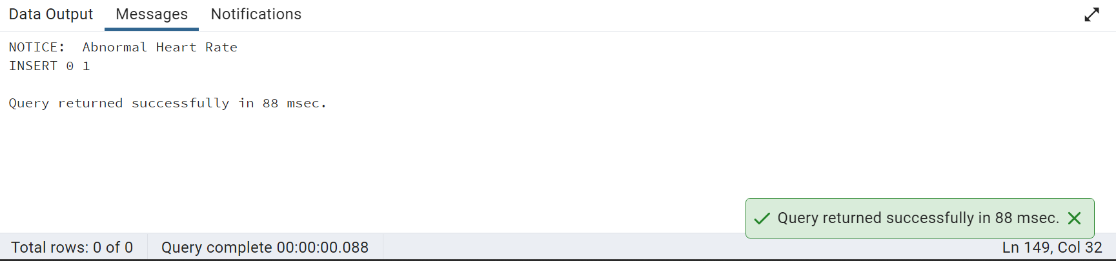

64 Write a query to find the number of Patients whose Gait RPE start is greater than the end and vice versa

SELECT 'RPE_END>START' AS type,COUNT ("Patient_ID") FROM public."Walking_Test"

WHERE ("Gait_RPE_Start " < "Gait_RPE_End " )

UNION

SELECT 'RPE_START>END'AS type,COUNT ("Patient_ID") FROM public."Walking_Test"

WHERE ("Gait_RPE_Start " > "Gait_RPE_End " )

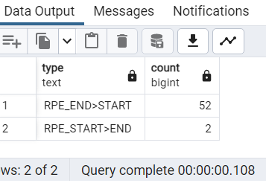

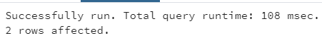

65)Create a view without using any schema or table and check the created view using a select statement.

CREATE TABLE Customers

(customer_id int NOT NULL,

customer_name char(50) NOT NULL,

address char(80),

place char(25));

INSERT INTO Customers(customer_id,customer_name,address,place )

VALUES(1,'NICK','ADDRESS2','USA');

CREATE VIEW CustomerViews AS

SELECT customer_id, customer_name, address, place

FROM Customers;

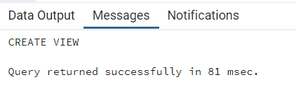

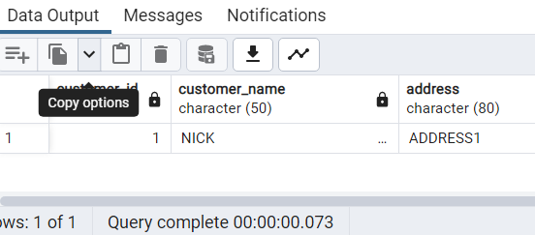

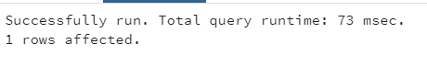

66)Display patients names who have the same last name.

select "Firstname","Lastname"

from "Patients" P

where exists (select "Firstname","Lastname"

from "Patients" P2

where P2."Lastname" = P."Lastname"

and P2."Patient_ID" <> P."Patient_ID")

order by "Lastname"

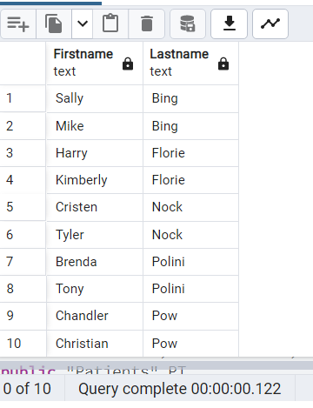

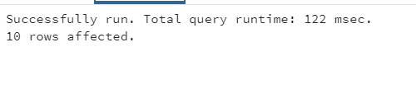

67)Write a query to get the Sum of Diabetes Duration for Group id 'GRP_02'.

SELECT SUM("Diabetes_Duration") FROM public."Patients"

WHERE "Group_ID"= 'GRP_02';

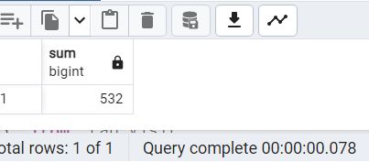

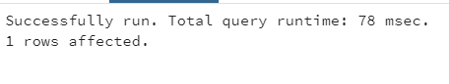

68)Write a query to get a patient name who has a chance to have kidney disease with Albumin.

SELECT CONCAT (A."Firstname" || ' ' || A."Lastname") AS "Patients_Albumin"

FROM "Patients" A

INNER JOIN "Link_Reference" B ON A."Link_Reference_ID" = B."Link_Reference_ID"

INNER JOIN "Urine_Test"C ON B."Urine_ID" = C."Urine_ID"

WHERE "Albumin" >= '30';

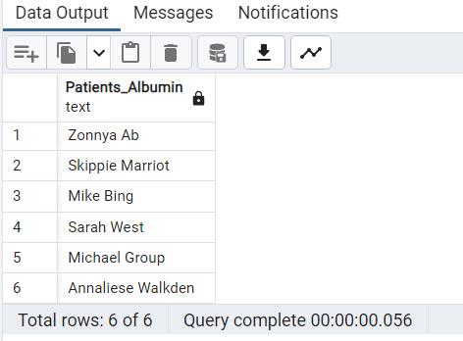

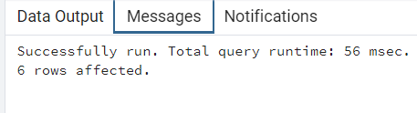

--69) Get the patient's name who has a max speed.

SELECT PT."Firstname",PT."Lastname","Gait_DT_Speed" FROM public."Walking_Test" W

JOIN public."Patients" PT

ON PT."WalkTest_ID" = W."WalkTest_ID"

ORDER BY "Gait_DT_Speed" DESC LIMIT 1;

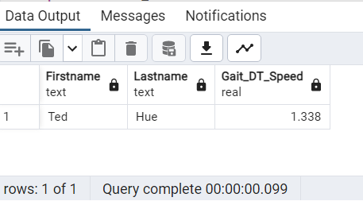

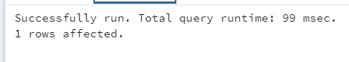

70.Write a query to find out the percentage of Lab visits by Lab names.

SELECT "Lab_names", (count(*)/ SUM(count(*)) OVER ()) * 100 AS percentage

FROM public."Lab_Visit"

GROUP by "Lab_names";

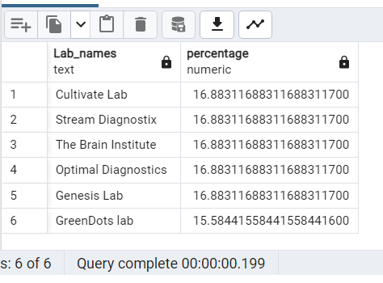

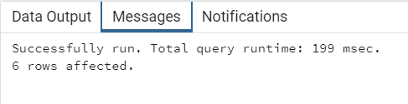

71) Write a query to get Patient IDs for verbally cognitively impaired who satisfy any 2 conditions.(HINT: dementia/cognitive impaired: any patient who has any two abnormal test results)

SELECT VC."Patient_ID"

FROM public."Verbal_Cognitive" VC

JOIN public."Link_Reference" LR ON VC."VC_ID" = LR."VC_ID"

JOIN public."Memory_Cognitive" MC ON LR."MC_ID" = MC."MC_ID"

WHERE (

(CASE WHEN VC."DS" <= 13 THEN 1 ELSE 0 END) +

(CASE WHEN VC."HVLT" <= 14 THEN 1 ELSE 0 END) +

(CASE WHEN VC."VF" <= 42 THEN 1 ELSE 0 END) +

(CASE WHEN VC."WTAR" <= 20 THEN 1 ELSE 0 END) +

(CASE WHEN MC."GDS" >= 15 THEN 1 ELSE 0 END)

) >= 2;

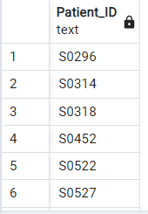



72) Display a list of patients who are memory cognitively impaired with the GDS test and whose diabetes duration is between 5 to 30.

SELECT P."Patient_ID",P."Firstname",P."Lastname"

FROM public."Patients" P

JOIN public."Link_Reference" LR ON LR."Link_Reference_ID" = P."Link_Reference_ID"

JOIN public."Memory_Cognitive" MC ON MC."MC_ID" = LR."MC_ID"

WHERE P."Diabetes_Duration" BETWEEN 5 AND 30

AND MC."GDS" >= 15;

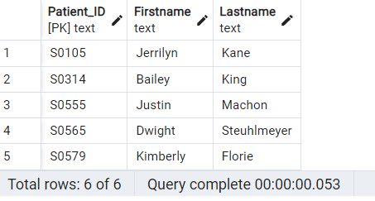



73) Write a query to the get number of Patient_IDs who visited between March 2005 and March 2006

SELECT COUNT(DISTINCT "Patient_ID") AS num_visits

FROM public."Patients"

WHERE "Visit_Date" >= '2005-03-01' AND "Visit_Date" < '2006-04-01';

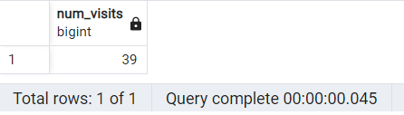



74) Get the number of patients who visited each lab using the windows function.

SELECT LV."Lab_names",COUNT(DISTINCT P."Patient_ID") AS Patient_Count

FROM public."Lab_Visit" LV

JOIN publ*ic."Link_Reference" LR ON LV."Lab_visit_ID" = LR."Lab_visit_ID"*

*JOIN public."Patien*ts" P ON LR."Link_Reference_ID" = P."Link_Reference_ID"

GROUP BY LV."Lab_names";

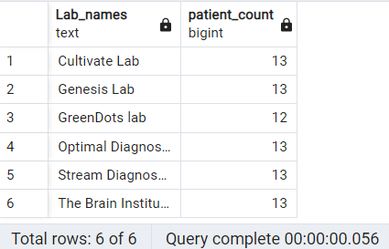



75) Find the number of control and DM patients who visited each lab.

SELECT G."Group",LV."Lab_names",COUNT(DISTINCT P."Patient_ID") AS Patient_Count

FROM public."Group" G

JOIN public."Patients" P ON G."Group_ID" = P."Group_ID"

JOIN public."Link_Reference" LR ON P."Link_Reference_ID" = LR."Link_Reference_ID"

JOIN public."Lab_Visit" LV ON LR."Lab_visit_ID" = LV."Lab_visit_ID"

GROUP BY LV."Lab_names",G."Group_ID";

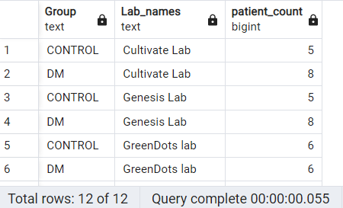



76) Please go through the below screenshot and create the exact output.

SELECT CONCAT("Firstname", ' ',"Lastname") AS Fullname,

LENGTH(CONCAT("Firstname", ' ',"Lastname"))+1 as unkown

FROM public."Patients";

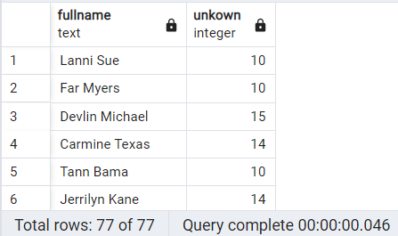



77)Write a query to get comma-separated values of patient details .(Use a maximum of 6 columns from different tables)

SELECT

CONCAT(

P."Patient_ID", ',',

G."Group", ',',

R."Race", ',',

GD."Gender", ',',

O."Diabetic_Retinopathy", ',',

LT."Fasting_Glucose"

) AS PatientID_Group_Race_Gender_Diabetic_Retinopathy_Fasting_Glucose

FROM public."Patients" P

JOIN public."Group" G ON P."Group_ID" = G."Group_ID"

JOIN public."Race" R ON P."Race_ID" = R."Race_ID"

JOIN public."Gender" GD ON P."Gender_ID" = GD."Gender_ID"

JOIN public."Link_Reference" LR ON P."Link_Reference_ID" = LR."Link_Reference_ID"

JOIN public."Opthalmology" O ON O."Opthal_ID" = P."Opthal_ID"

JOIN public."Lab_Test" LT ON LT."Lab_ID" = LR."Lab_ID"

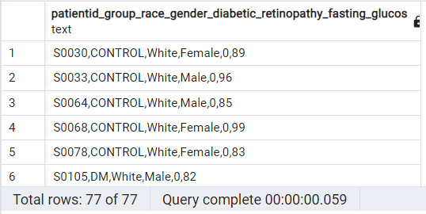

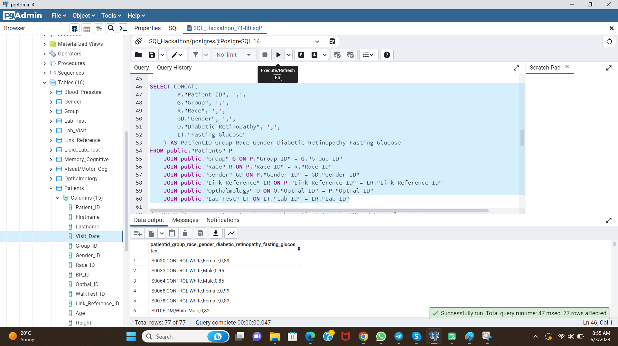

78) Write a query to determine get the Patient IDs ,in DM and Control groups ,

that are in prediabetic stage and label them accordingly.

SELECT P."Patient_ID",G."Group",

CASE

WHEN LT."Fasting_Glucose" BETWEEN 100 AND 125 THEN 'Prediabetic'

WHEN LT."Fasting_Glucose" > 125 THEN 'Diabetic'

ELSE 'Normal'

END AS Label

FROM public."Patients" P

JOIN public."Group" G ON G."Group_ID" = P."Group_ID"

JOIN public."Link_Reference" LR ON LR."Link_Reference_ID" = P."Link_Reference_ID"

JOIN public."Lab_Test" LT ON LT."Lab_ID" = LR."Lab_ID";

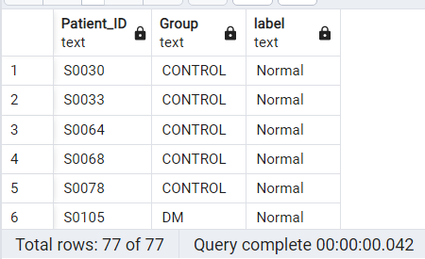



79) Calculate the Patient's Daytime MAP and Nighttime MAP.

SELECT P."Patient_ID",

CAST((BP."24Hr_Day_DBP" + ((BP."24Hr_Day_SBP" - BP."24Hr_Day_DBP") / 3.0)) AS numeric(10, 2)) AS daytime_map,

CAST((BP."24Hr_Night_DBP" + ((BP."24Hr_Night_SBP" - BP."24Hr_Night_DBP") / 3.0)) AS numeric(10, 2)) AS nighttime_map

FROM public."Patients" P

JOIN public."Blood_Pressure" BP ON BP."BP_ID" = P."BP_ID";

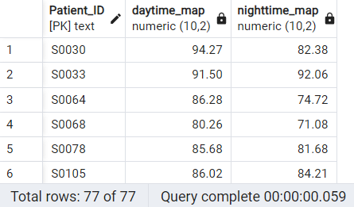



80) Write a query using recursive view.

WITH RECURSIVE GP_01 AS (

SELECT "Patient_ID", "Group_ID", "Firstname"

FROM public."Patients"

WHERE "Group_ID" = 'GRP_01'

UNION

SELECT p."Patient_ID", p."Gender_ID", p."Firstname"

FROM public."Patients" p

INNER JOIN GP_01 s ON s."Patient_ID" = p."Group_ID")

SELECT "Patient_ID","Firstname","Group_ID"

FROM GP_01;